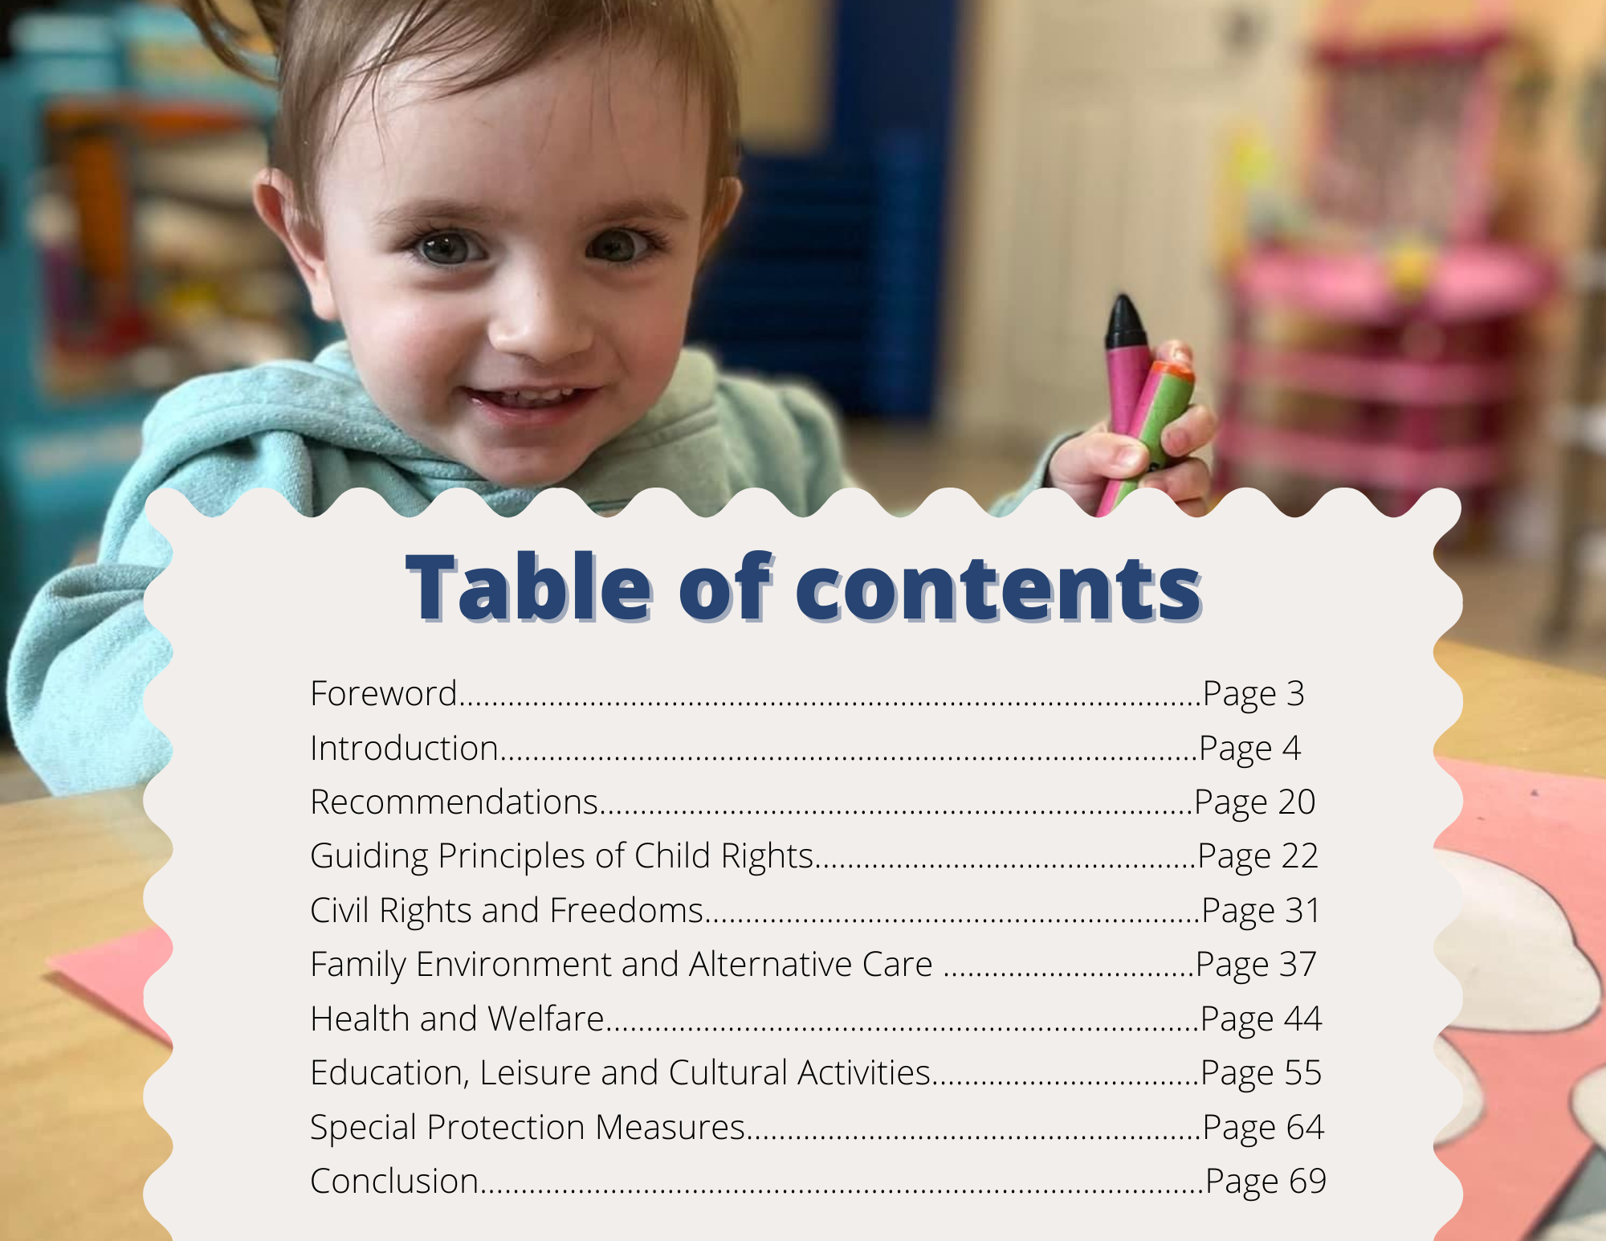
FOREWORD
Children do not grow up at the speed of government study and that is why rights matter.

Governments balance interests and distribute scarce resources. For that reason, much of what they do is conditional – upon time, upon agreements, upon reflection, and that old standby, “given adequate resources”. Choices can be deferred, delayed, taken under advisement and, of course, studied.

Rights disrupt the language of “might”. They require a culture of “must”. Children, often vulnerable and without formal or informal political power, rely upon a culture of “must” for their development, safety and opportunity.

The child who struggles to read and is losing hope in school, the child who is bewildered navigating a courtroom, the child in care aching for a family, and the child with disabilities who needs support to have the friends and activities and hope of their peers; these children all rely upon us taking their interests as “musts”. When government “can” help, the child often falls behind those who can vote, organize, donate and speak out. When government “must” help at first instance, there is hope.

That is why our office regularly updates New Brunswickers on the state of child rights. It is why we recently pushed, with some success, for the Legislature to amend the new Child & Youth Well-Being Act, to entrench children’s rights in explicit language. It is why our office takes a rights-based approach to the issues we confront, whether advocating for an individual or for system-wide changes.

In this report, we have tried to look at where we stand, as a province, in the things we must do for children. Your interest in these rights is appreciated.

Kelly A. Lamrock, Q.C.
New Brunswick Child and Youth Advocate

INTRODUCTION
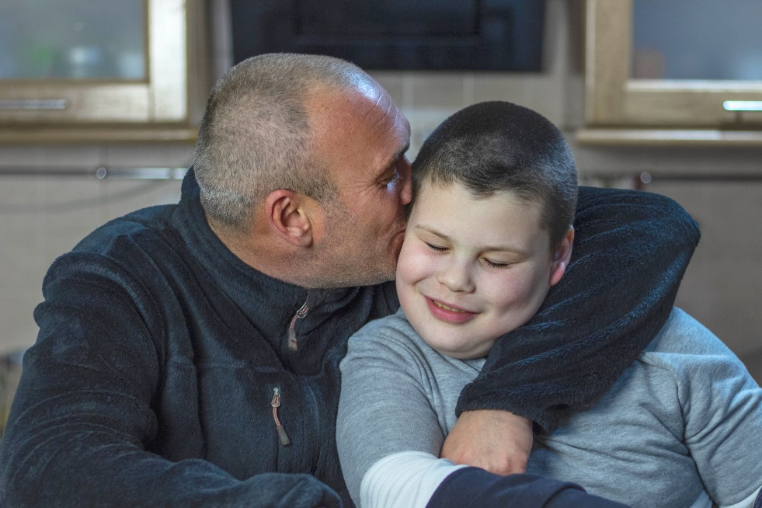

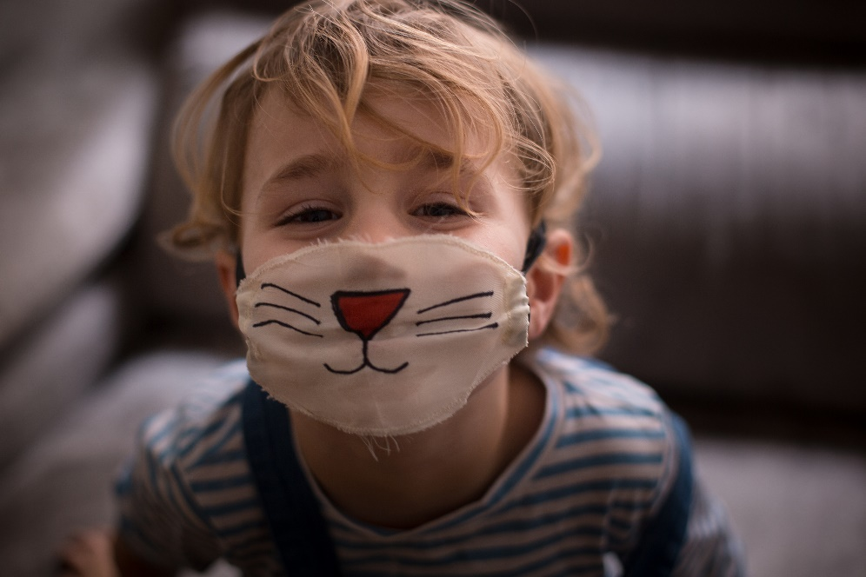
“All human beings are born free and equal in dignity and rights”. These words solemnly affirmed in the UN Charter and in human rights instruments the world over are the foundation of human rights, democracy, and the rule of law. And yet, from the moment these principles have been affirmed, human beings have struggled to have these central values of freedom and equality enforced and respected for all. The progressive march of human rights from the time of the Second World War and the period of decolonization forward can be understood as a series of succeeding battles for racial equality, for equality between men and women, for equality for persons with disabilities, for minority, sexual orientation, and gender communities, for indigenous rights, etc.

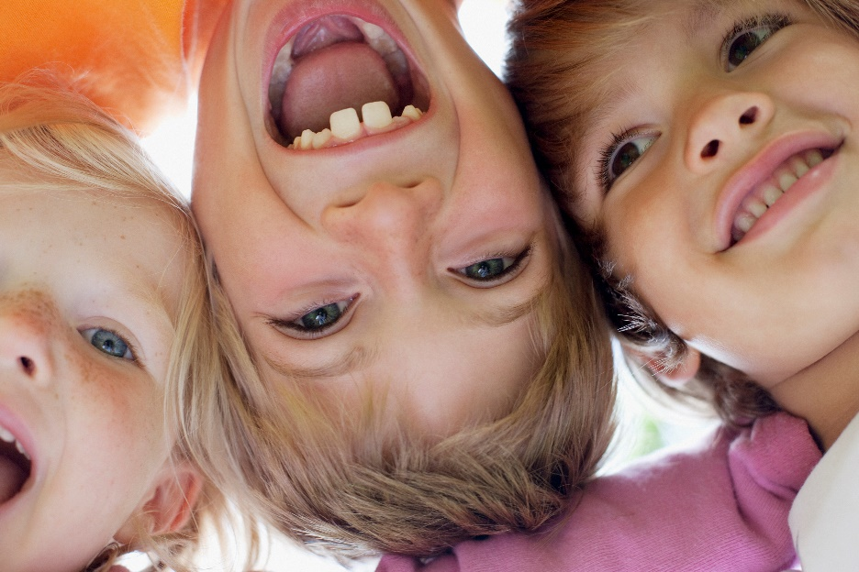
Indeed, all human experience confirms to us that none of us are born equal in prowess, strength, intellect, or any other ability. All of us, moreover, are born into abject vulnerability. We are totally dependant on our parents and community for many years, more so than any other creatures on earth. Equality is always an aspiration for every human child. We claim it as a birthright because our sense of human dignity requires this. But this right to equality is a tenuous claim in every case and needs careful nurturance in the best of cases. In many cases, the road to respecting our equal human dignity will be fraught with difficulty and challenges. Many of us will, in fact, experience more challenges than others, finding more roadblocks, more opposition, and more intolerance, even as some of us age our peers in the community seem to advance with every advantage along a comfortable yellow brick road. Parents of children with disabilities are well aware of these divergent paths. As for children with disabilities themselves, their knowledge of their parents’ love may shield them from discrimination for many months, but they will also have to meet up with it and compose with it as they age.

This year the Annual State of the Child report offers a special focus on children with disabilities and the protection of their rights under Article 23 of the Convention as well as under the Convention as a whole. This is also the first time we have released the State of the Child report separately from the Child Rights Indicator Framework. Moving forward, this will increase the opportunity for public engagement and dialogue around child rights data monitoring and allow the Advocate more time for better analysis of the data sets as they become available. This new schedule of reporting has also been timed to provide an up-to-date snapshot and data analysis to inform the theme of our annual summer course on the right of the child in partnership with the Université de Moncton, which this year is also focused on Article 23 and the rights of children with disabilities. Unless otherwise referenced all statistics were obtained from The Child Rights Indicator Framework 2021.

As in previous years, the report will begin with this special focus and then turn to an analysis of what new trends appear in the data updates from the last year, looking at the data disaggregation overall while keeping particularly in mind the data gaps and challenges faced by children with special needs and disabilities in general.

Special Focus on the Rights of Children with Disabilities and Special Needs
Article 23: 1. States Parties recognize that a mentally or physically disabled child should enjoy a full and decent life, in conditions which ensure dignity, promote self-reliance and facilitate the child's active participation in the community.
2. States Parties recognize the right of the disabled child to special care and shall encourage and ensure the extension, subject to available resources, to the eligible child and those responsible for his or her care, of assistance for which application is made and which is appropriate to the child's condition and to the circumstances of the parents or others caring for the child.
3. Recognizing the special needs of a disabled child, assistance extended in accordance with paragraph 2 of the present article shall be provided free of charge, whenever possible, taking into account the financial resources of the parents or others caring for the child, and shall be designed to ensure that the disabled child has effective access to and receives education, training, health care services, rehabilitation services, preparation for employment and recreation opportunities in a manner conducive to the child's achieving the fullest possible social integration and individual development, including his or her cultural and spiritual development
4. States Parties shall promote, in the spirit of international cooperation, the exchange of appropriate information in the field of preventive health care and of medical, psychological and functional treatment of disabled children, including dissemination of and access to information concerning methods of rehabilitation, education and vocational services, with the aim of enabling States Parties to improve their capabilities and skills and to widen their experience in these areas. In this regard, particular account shall be taken of the needs of developing countries.

Article 23 of the UNCRC, like several of the Convention’s provisions, was a precursor of human rights developments to come. Just as article 31 provides rights to indigenous children long before the UN Declaration on the Rights of Indigenous Peoples was ever adopted, so too does Article 23, from 1989 forward, affirm the rights of children with disabilities long before the rights of all persons with disabilities were affirmed in the 2006 UN Convention on the Rights of Persons with Disabilities.

Article 23 has four main attributes as set out in its several clauses: i) it affirms the core value of disability rights by affirming the fundamental right to inclusion, to a full and decent life of dignity and active participation in the community; ii) it guarantees access to special care and assistance appropriate to the child’s condition and circumstances; iii) it insists that the special care and assistance offered must be made available free of charge and designed to ensure that the child obtains access to education, health, recreation,
rehabilitation and employment services in order to achieve their full inclusion; and
iv) it insists upon the need for international cooperation in achieving implementation of this right around the world.
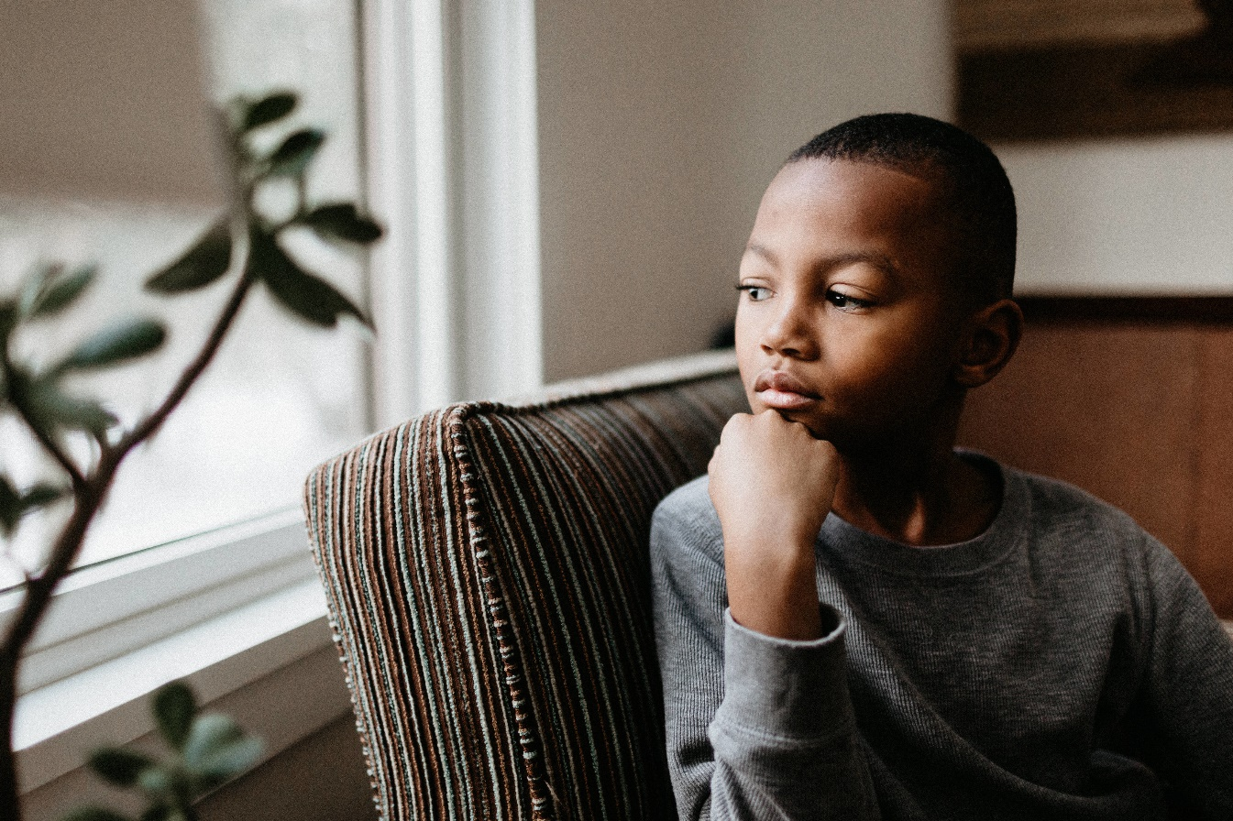
In New Brunswick, the Province has just adopted a new Child and Youth Well-Being Act. The new legislation carries forward the Minister’s authority to offer support and social services to children with disabilities. It couches that legislative authority, however, in non-binding permissive language. Section 26 of the statute says only that “The Minister may provide social services, including support, to the family of a child or youth with a disability to address the particular developmental needs of the youth.” Moreover, where the Family Services Act had a preamble that gave a clear legislative intent to affirm the rights of the child and recognized that the rule of law guarantees these rights and that the rule of law likewise governs the Province’s intervention into the affairs of individuals and families, the new act has no preamble, nor does its purpose clause or statement of principle speak of any rights of any child, such as might require a strict reading of this provision to interpret “may” as “shall”. And yet, to be consistent with our promises to children and our undertakings in relation to our international legal obligations to children and governments elsewhere, “may” must mean “shall” in a legislative provision of this sort.
What is regrettable is this ambiguity and the missed opportunity to affirm for children here and their families that their government recognizes that its obligation to support families of children with disabilities is not the result of the partisan political priorities of one government or another but is, in fact, a legal obligation of government, stemming from our recognition of the fundamental rights of children with disabilities. This is not a matter of federal jurisdiction. This is not an obligation that the Province can or should pass down to local governments. Only the Province has the authority to recognize these fundamental rights of this vulnerable class of children in our law. Nor should the message to families of children with disabilities be that raising the child is all on them or that government will only help where it can afford to do so. When we fail to recognize these fundamental rights of children, we give license to a commonly held view that families need to look after their own or that disability supports are a form of charity rather than a right. We could and should have taken this time of law reform as an opportunity to lead the country and strongly affirm the rights of disabled children and other child rights. Instead, our failure to act allows other provincial governments and territories to do the same and ignore the rights of our most vulnerable citizens.
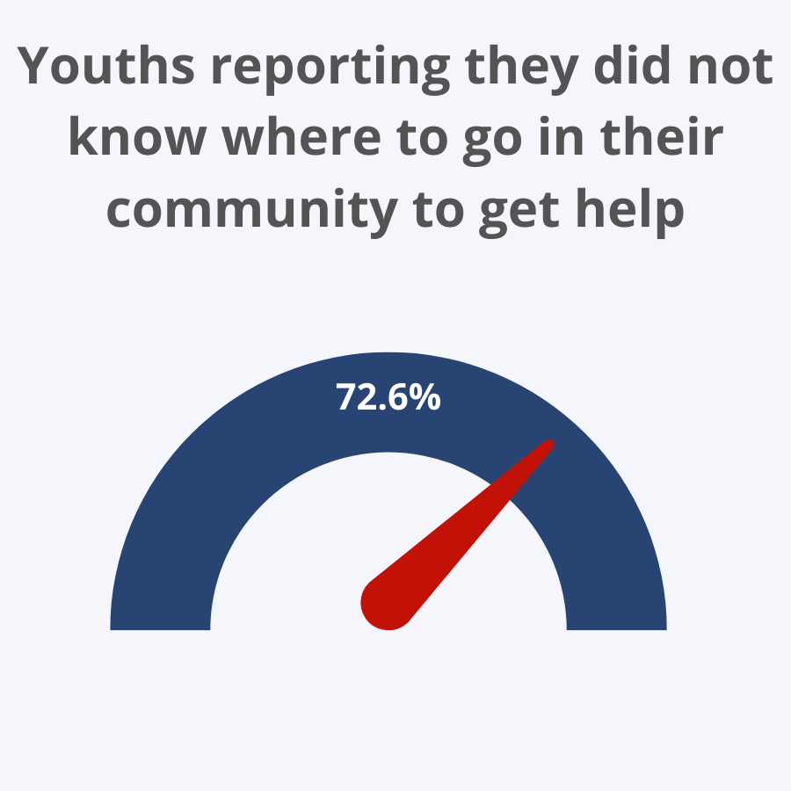

disability have proven challenging for families with disabilities concerning pension plans, tax relief, income assistance and other supports. An extensive liberal interpretation of the new provisions consistent with their purpose, child rights and the best interests of children with disabilities is what program administrators, courts and tribunals will have to use for guidance. Hopefully, as the new legislation is administered, interpreted and applied, those purposive views will hold the day and children in need will not needlessly be denied support.
Our concern is that as time unfolds, new legislative gaps or weaknesses in the legislative scheme will be exposed. Too few people and stakeholders engaged in the implementation and application of this vital law were provided with an opportunity for input. Our initial analysis led to twelve recommendations, most of which were quickly actioned by the Government based on the floor amendments, actioned within the week - which is never an ideal way of proceeding with law reform. While the new Act requires a mandatory review within five years of this spring and every seven years after that, we would urge the Government to diary date June 2025 as the time to commence that first five-year review. This would provide ample time developing legislative proposals, consultation based on the proposed draft amendments and then a robust debate within the legislature and study in committee, with time for fulsome submissions by all stakeholders at the committee stage. Express consideration should be given in that review to how to best protect and advance the rights of children with disabilities.
In the meantime, careful consideration needs to be given to how we measure our investments and support for children with disabilities and the impact we are having. We are pleased to note the requirement in the new Act in section 18 to monitor outcomes and social services, support, and activities offered to children. Still, we would urge the Department to be careful in its data collection efforts to collect the necessary biographical data to allow for appropriate disaggregation and reporting on outcomes for certain classes of vulnerable youth, including LGBTQ+ youth, indigenous and racial minority youth and children with disabilities, as well as youth in care, by care status. We need to be asking ourselves as a Province whether we are doing enough across child well-being systems, education, sport and recreation systems and health interventions to give children with disabilities the equal playing field they deserve. Have they been equipped to achieve their full potential in New Brunswick for a life with dignity and active participation in the community? Does New Brunswick remain fiercely committed to the goal of equal opportunity that has been the touchstone of successive governments since the 1960s? If children with disabilities are not currently afforded equal opportunity, how does that reflect upon New Brunswick? What are other measures required to support this goal of true equality and better outcomes for children with disabilities? How can we put these measures in place?
One example is the encouraging news this spring concerning the significant and much-needed investment in FASD diagnostic and intervention services through the NB FASD centre of excellence. The $800,000 investment announced by Minister Shepard on June 9th will provide much-needed support to families of children with FASD. FASD affects an estimated 30,000 New Brunswickers according to national prevalence studies, including over 4000 school-aged youth. Most of these cases may, as of yet, be undiagnosed. The annual costs of FASD in education supports, health supports, justice services and social services for each client with FASD
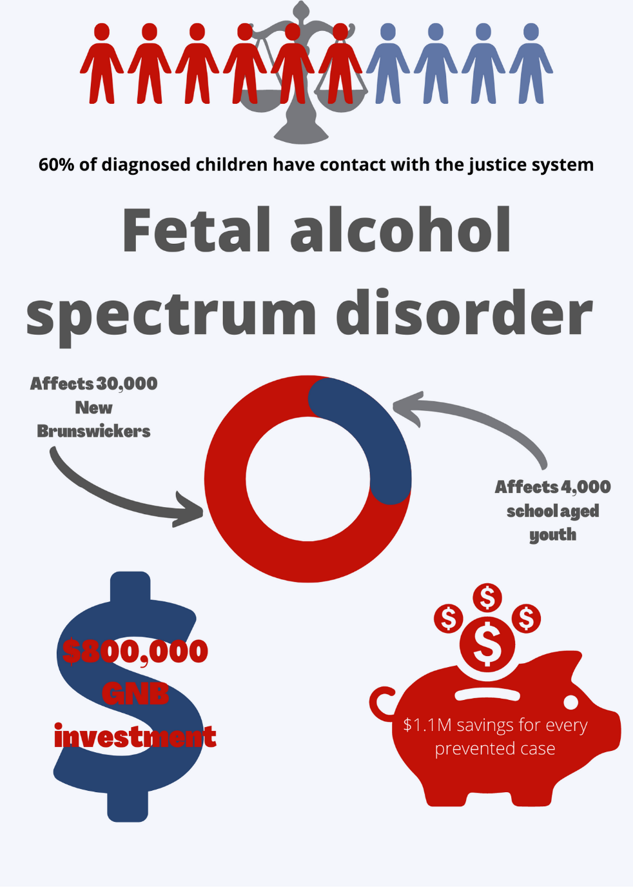

is estimated to be over $27,000 yielding $1.1 million in savings over a lifetime for every case avoided. With proper prevention programming, many cases of FASD are avoidable.
Sixty percent of children diagnosed with FASD report having contact with the justice system; and are 19 times more likely to be imprisoned than their peers. A review of the New Brunswick Centre of Excellence’s caseload in 2020 determined that half of the children diagnosed by the centre had a formal care status with the Province. Beyond the economic impacts of our failure to address FASD, we also have to look to the human costs, knowing that FASD-diagnosed youth have an average life expectancy of merely 40 years owing to comorbidities and the high rate of suicide among this population. These devastating impacts affect families and caregivers in myriad ways.
In recent months the Advocate’s Office has expended considerable effort to insist upon alternatives to prosecution for youth with FASD and other neurodevelopmental delays. This is in keeping with the guidance from the Committee on the Rights of the Child which, insists on the child’s right to an adapted youth criminal justice system under Article 40 of the Convention. This provision requires that States establish a minimum age of criminal responsibility below which prosecutions may not be brought but that prosecutions of children with a neurodevelopmental delay not be brought at all. This only stands to reason. If we agree that children below a certain age are not morally culpable, then it doesn’t make sense to prosecute children who have reached a certain chronological age but suffer from neurodevelopmental delay. This is a grossly unfair miscarriage of justice which violates their security of the person, their liberty, their right to equality, their right to a separate system of criminal justice and their right to special measures of protection as children with disabilities. As Advocates, we are calling upon members of the bar and the bench to defend the rights of these children assiduously and advance the law in Canada in this respect. The Federal Parliament could also act to give effect to this direction from the Committee on the rights of the child, but until they do, provincial Attorney Generals have a responsibility to look to their prosecution manuals and practice and determine whether our approach needs to change.
We are very pleased to note that the Advocate has recently received a grant from the Provincial Attorney General’s Office to work with a broad array of justice, policing and corrections services partners, including their community allies and First Nations intervention workers, to develop child-friendly justice standards in New Brunswick provincial courtrooms and practice, over the 2022-23 calendar years. The issue of prosecutions of children with neurodevelopmental delay and how best to divert these cases will be one of several focal points of our discussions.
It is well past time for the Province of New Brunswick to develop a responsible alcohol policy that addresses the teratogenic effects of alcohol. Teratogen refers to a substance that is a known agent of malformations in an embryo. Alcohol is a known teratogen, and its consumption during pregnancy prevents the normal development of brain cells and causes permanent damage that can have life-long impacts. Pregnancies in Canada are increasingly unplanned, with some jurisdictions reporting as many as 60% of pregnancies being unplanned. With alcohol sales having spiked almost 30% during the pandemic, according to some estimates, and with the isolation required by public health measures, experts are concerned that rates of FASD may increase in the coming years. Indeed, the diagnosis rate will increase with the expansion of diagnostic services and greater knowledge and awareness of the benefits of clinically guided interventions. As liquor sales are provincially regulated and an important revenue source for the Province, the Province bears a heavy responsibility to reduce the health burden of alcohol consumption, especially now for children in utero, as the impacts of alcohol consumption become better known. The Province should act quickly to shoulder this responsibility and address it before someone asks the courts to make them do so.
Our review of the data in the last Child Rights Indicator Framework confirms that across many indicators, children with special needs are disproportionately at greater risk of having lower scores on indicators of resiliency and protective factors and are more likely to engage in risky behaviour or be susceptible to risk factors in their community. This is true across all domains or clusters of rights, as addressed in the report below. Especially disquieting is the fact that students with special needs rarely seem to report outcomes that outpace the average of their age peers. Some notable exceptions seem to be their participation in arts activities and other clubs in schools which is marginally higher than their age peers’ participation overall. Overall Special needs children seem to be the population at greatest risk after children in food-insecure households and lbgtq+ children and youth. Not only are the outcomes reported by special needs youth generally less encouraging across all indicators, but many indicators also show a spread of over 15% points in terms of an achievement gap with their peers. For instance, special needs youth are much more likely to have received a diagnosis of a mental health disability (22% versus 6%); they report symptoms of anxiety and depression at a far greater rate than their peers (53% versus 37% in both cases). They are far less likely to report having had opportunities to take fine arts courses in high school (46% versus 71%) or to have had career-related learning experiences in high school (47% versus 63%). At least ten other indicators showed a gap of over ten percentage points, including their self-reports for having their need for competence highly satisfied, their need for autonomy highly satisfied, their self-reported moderate to high level of resilience and moderate to high level of mental fitness, their experience of bullying, their report of mental fitness needs being highly satisfied by their families and their report of being able to solve problems without harming themselves or others.
All in all, the picture is not so much that disabled children are challenged by their disabilities; instead, they are challenged by their peers, by families who are not sufficiently supported to support them, by systems that do not meet their needs or allow them to flourish and by systems that fail to meet their emotional needs and undermine their self-worth. Clearly, as a Province, we must do better. We need to place more resources and more emphasis on addressing these inequalities. A closer analysis of each of the clusters of rights under the Convention in the Child rights Indicator framework will bear this out.

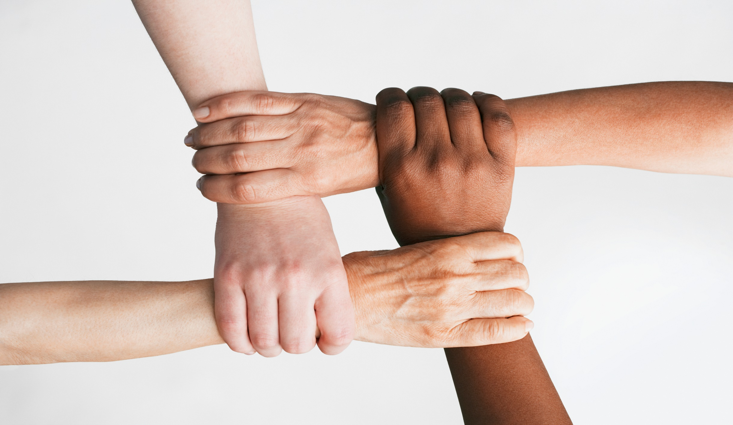
RECOMMENDATIONS

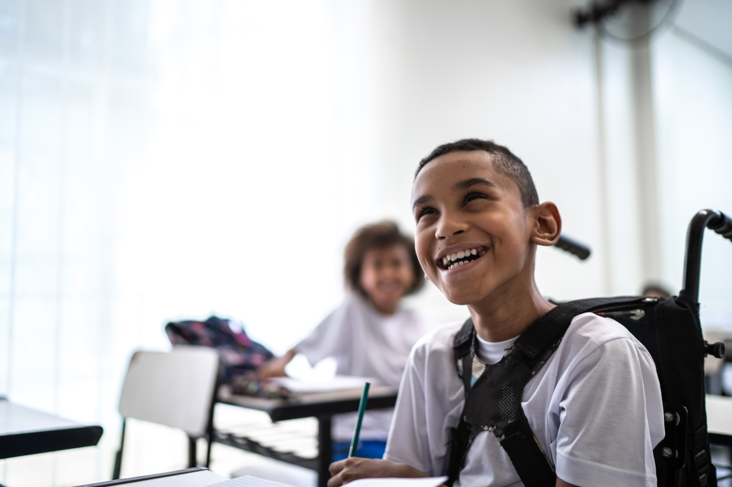
O
GUIDING PRINCIPLES OF CHILD RIGHTS
One of the defining aspects of children’s rights is that all child rights, like human rights in general, are indivisible. This means you cannot give precedence to one right over another or trade one against another. All rights are equally important, and violating any fundamental right should give rise to a clear remedy. All rights also take meaning and contour by interpretation and application to other rights. Child rights experts and courts worldwide have long agreed that with the Convention’s forty substantive rights guaranteed to children, at least four stand out as guiding principles. These rights must be considered and applied in every case involving an allegation of a child rights violation. In other words, in addition to being substantive rights of their own, they are general guiding principles of child rights. The data in the most recent Child Rights Indicator Framework shows that we still have much progress to make in the realization of these fundamental rights and guiding principles of child rights in New Brunswick, whether in terms of equality, best interests of the child, a child’s right to life, survival and maximum development, their right to participate in decisions which affect them. To these four guiding principles, we add a fifth, captured in Article 5 of the Convention and the treaty’s general emphasis on the child’s human dignity. This principle - of particular import to children with disabilities – is their right to parental guidance in exercising all their rights and development in accordance with their evolving capacities and equal human dignity.
The indicators available under the Guiding Principles section of the Child Rights Indicator Framework are drawn mainly from the Student wellness survey, and it contained relatively little new data in 2021. As we undertake a pilot of the GlobalChild child rights data monitoring platform in New Brunswick this year, it will be essential to look at this set of indicators in the CRIF and consider how more structure and process indicators can be added to the framework as the wellness indicators are invariably outcome indicators based upon student self-report. We should also be measuring as a province what laws, institutions, regulations, strategies, policies, and programs we have in place to implement general principles of child rights.

Equality and Non-Discrimination
Equality and non-discrimination is the first general principle that serves as a guide to the interpretation of all children’s rights under the Convention on the Rights of the Child. Discrimination has countless adverse effects on children and violates their human rights. Under Article 2, state parties, including Canada, must ensure that the rights found in the Convention are respected and enjoyed regardless of race, colour, sex, language, religion, political or other opinions, national, ethnic or social origin, property, disability, birth or other status. Additionally, children must be protected from discrimination or punishment based on the status, activities, expressed opinions, or beliefs of the child's parents, legal guardians, or family members.
As in previous years’ reports, the data disaggregation continues to show a very sharp disparity between children in lower-income households and their peers, as well as LBGTQ+ children and their peers. 25% of LGBTQ+ youth felt unsafe in school compared to 16.6% of boys and 15.6% of girls. This is a significant disparity and is likely associated with the discrimination or intimidation they experience at school. Furthermore, many youths with special needs and Indigenous youth don’t feel like something is done when they report bullying incidents to adults. Specifically, 64.4% of youths with a disability and 64.7% of Indigenous youth hold this sentiment.
Alarmingly, a high percentage of youths reported being bullied at school during the 2018-2019 school year. Among this data, children with special needs and LGBTQ+ youths form part of the highest percentage of reported bullying with, 61.8% and 64.1%, respectively. However, youths in low-income households have the highest reported bullying rate (70.7%). These three groups also reported being excluded more at school by their peers than their counterparts.
New Brunswick’s school systems need to ensure that they are implementing effective bullying prevention programs and have protocols to respond to incidents of discrimination and bullying. Children have a right to feel safe at their school and have confidence that the staff will respond to incidents of bullying when it is brought to their intention.
Best Interests of the Child
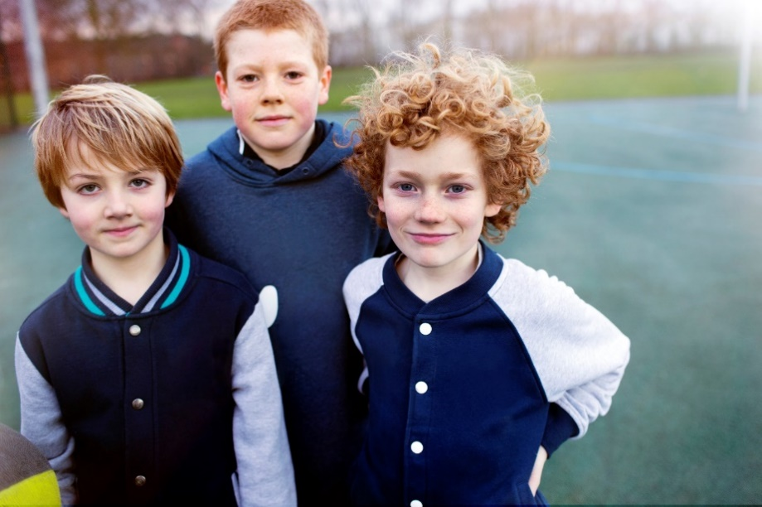
The second general principle found under Article 3 of the Convention is the best interests of the child. It is crucial that the best interest of the child is the primary consideration in any decisions taken by courts, administrative decision-makers, social welfare institutions, or legislative bodies. Essentially, any decisions that have or could have an impact on a child must be made with their best interests in mind. The well-being and security of a child must form part of that consideration. Decisions are taken in the best interests of the child if they consider and take into account the youth’s views and preference, their physical, mental, and emotional well-being and individual needs, and their cultural, linguistic, religious and spiritual heritage, including Aboriginal heritage, and their sexual orientation, gender identity and gender expression.
It is also the State Parties’ responsibility to ensure that the institutions, services and facilities responsible for the care or protection of children shall conform with the standards established by competent authorities, particularly in the areas of safety, health, the number and suitability of their staff, as well as qualified supervision. To achieve this, however, it is crucial to provide a uniform definition of the best interests of the child. This was recently acknowledged by the Committee on the Rights of the Child’s (CRC) Concluding Observations for Canada, who reiterated the importance of the best interests of the child being the primary consideration in every decision that impacts them.

Their recommendation to the State party was the following:
Ensure…the best interests of the child is appropriately integrated and consistently interpreted and applied in all legislative, administrative and judicial proceedings and decisions as well as in all policies, programmes and projects that are relevant to, and have an impact on, children.

However, to be consistently interpreted in legislation, administrative and judicial proceedings and decisions, decision-makers must understand and have access to a well-founded characterization of the best interests of the child. Overall, only 37.4% of 6-12 grade students reported they are treated fairly in their community. Among this population, 82% of youths with food insecurities and 75% of LGBTQ+ children felt as though they were not treated fairly in their community. It is crucial that youth’s voices are heard, and their opinions are respected when decisions are being made that concern them. They must be treated fairly, including making decisions that are in their best interest while considering their individualized needs, personal background, and preferences.
A significant number of youths reported that they did not know where to go in their community to get help. A total of 72.6% felt this, signifying that they did not know where to access services for support and resources. This is extremely alarming, especially considering that we are slowly exiting the pandemic and suicide rates, mental health struggles, fatigue, and homelessness are at an all-time high. Children need to know where to go within their community to access their required services. Services also need to be tailored to the child’s needs, such as therapy options for eating disorders or counsellors specializing in gender identity and expression. Among the student population, 82% of food insecure and LGBTQ+ youth did not know where to go in their community to get help. Promotion of and access to services and supports need to increase in our province drastically. 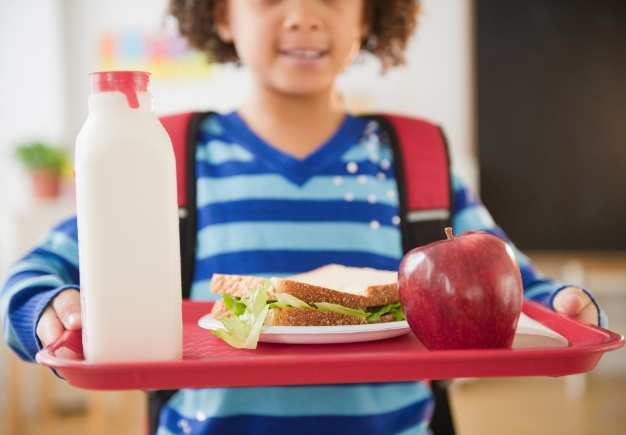

Life, Survival and Maximum Development
The third general principle under Article 6 of the Convention is the right to life, survival and maximum development, which affirms rights also found in section 7 of the Canadian Charter of Rights and Freedoms. Children must be in an environment that fosters mental, physical, social, and emotional development, whether at school, at home, or in the community.
As highlighted in our office’s recent report, The Best We Have to Offer, suicide rates are proportionately higher in our province than in other jurisdictions in Canada, and an effective response is needed to address this issue. Every child has a right to life and survival. Our province lacks adequate training for suicide intervention, specialized services, standardized risk assessment tools and practices to triage mental health cases, community-based care and services, and more.
In order to achieve developmental growth, youths must feel autonomous and competent. Although a large percentage of students felt competent (75.2%), 54.8% of food-insecure youth did not feel their need for competence was satisfied. In this same cohort, 60.2% of students reported that their need for autonomy was not satisfied. This could be attributed to the fact that food-insecure youth are not receiving nutritious meals that are essential for proper development. Hence, they are depend more on adults or school staff to provide them with food to meet their nutritional needs.
Resiliency is also a critical factor in a child reaching their maximum development. 71% of youth in grades 6-12 reported moderate to high levels of resiliency. However, only 57.9% of youth with special needs and 36.5% of youth with food insecurities felt as though they were resilient. Having effective coping skills, a stable environment, and a supportive community, especially at school, will help a child develop their resilience.

Child and Youth Participation
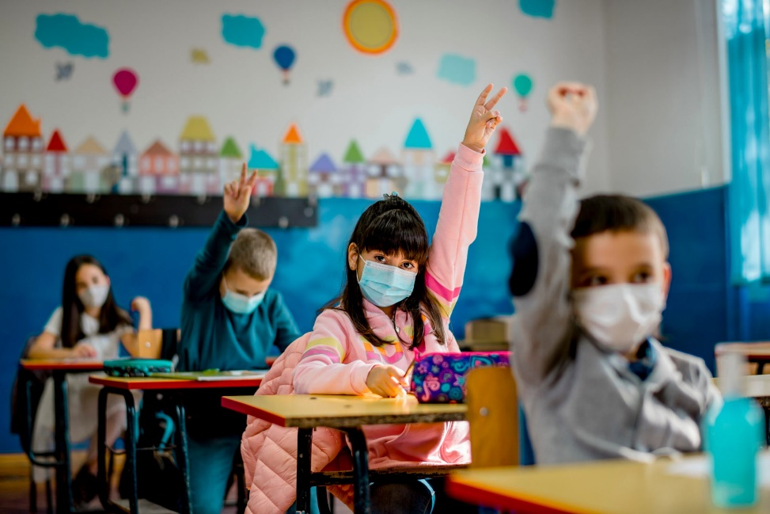
The fourth and final general principle is set out in Article 12 of the Convention. It stands for the proposition that any child capable of forming their own view must have the right to express those views freely in all decisions that affect them. Article 12 is strongly related to Article 3, the best interests of the child. Decision-makers must give these views due weight in accordance with the age and maturity of the child. The voice of the child can be heard directly or through a representative or an appropriate body.
Many policies and legislation acknowledge the right of all children to be heard including the new Child and Youth Well-Being Act. However, we still lack proper mechanisms to respect and implement this right in practice. As the CRC stated in their General Comment No. 12, “in most societies around the world, implementation of the child’s right to express her or his view on the wide range of issues that affect her or him and to have those views duly taken into account, continues to be impeded by many long-standing practices and attitudes, as well as political and economic barriers.”
Child-friendly courts, recordings of their testimonies,
written letters expressing their views, and judicial interviews are among a few examples of ways to effectively hear the voice of the child. State parties have a duty to provide an environment that enables the child to exercise the right to be heard.
Children belonging to marginalized and disadvantaged groups often face particular barriers in realizing this right. Overall, 35.5% of students reported that they did not think expressing their opinions in class was important. This sentiment was even more widely held among the LGBTQ+ students, food-insecure children, and youth with special needs. Youth spend most of their time at school, and it is important for them to feel like their views are heard and duly taken into account.

Evolving Capacity and Dignity
A number of commentators have suggested over the years that a fifth general principle under the Convention could be added concerning the Child’s evolving capacities. The central importance of this concept in Article 5 is reflected in the genesis of this provision as revealed in the travaux préparatoires to the Convention and the nexus between Article 5 and Article 18, as well as the liberty interests in Article 6 and Article 16. In our view, the disabled child’s claim to dignity and inclusion in Article 23 is bound up with these same questions around the child’s autonomy and liberty as guaranteed through these several provisions. Children, in general, have been objectified by legal systems for centuries. The common law, in particular, always considered children as chattel until the dawn of the 20th century. Children with disabilities are particularly at risk of paternalism and objectification. This is why their right to autonomy and their evolving capacity needs to be supported as much as possible in their best interests by all of the adult allies in their lives. The CRIF data highlighted above and below show how easy it is to overlook or lose sight of a particular child’s needs in relation to their disability and how the cumulative impact of those everyday oversights can beat down a child’s resilience or sense of self-worth. Moving away from deficit-based interventions, focusing on strength-based interventions and normalizing “just-in-time” interventions has to be the continued focus of our Integrated service delivery efforts, child and youth teams. Promising integrated care interventions such as ACCESS Open Minds, Child Advocacy Centres, FASD intervention centres and Social Pediatrics clinics exemplify these approaches and all need increased investments and support.

CIVIL RIGHTS & FREEDOMS
The Civil Rights and Freedoms section of the CRIF captures data related to the rights enumerated in articles 7,8,13,14,15,16, and 17 of the United Nations Convention on the Rights of the Child (UNCRC). These rights include the right to a name and identity, the right to a nationality, the right to freedom of conscience, thought and religion, privacy, and access to information from diverse sources.
These are clustered together as they reflect the ability of the child to develop their views, be legally cognizable to the state and participate in public life. This ensures maximum social and political development.
In General Comment 9, dealing with the rights of disabled children, the UN Committee on the Rights of the Child notes that “particular attention should be paid here on areas where the rights of children with disabilities are more likely to be violated or where special programmes are needed for their protection.” The Committee notes that of particular relevance to disabled children is the right to access information from diverse sources. Disabled children are particularly vulnerable as they may need access to alternative or specialized sources to realize this right. For instance, this could include sources of information in Braille or sign language and other accommodations depending on the nature of the disability. The Committee further advocates for accessible and free public transit as this is often key for disabled children to be able to participate in public life.

Indicators
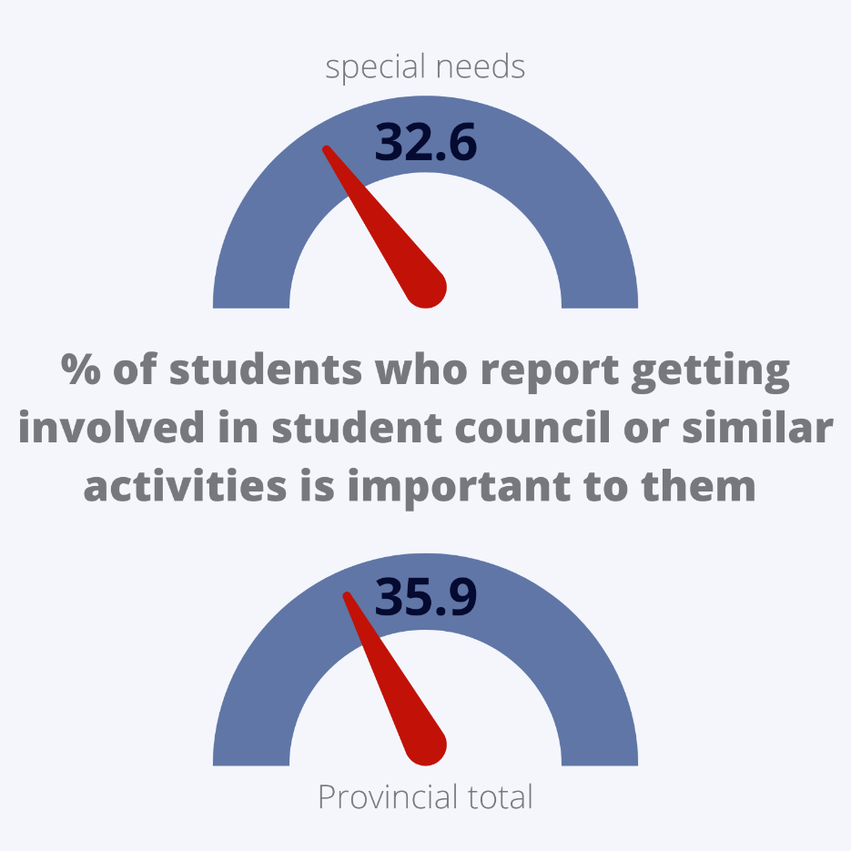
The indicators in this section paint a picture of the capacity of children and youth for social and civic engagement. There is a strong correlation between social capital and civic engagement. The indicators here examine factors such as the opportunities for children and youth to engage in clubs or community groups in and out of school. High levels of engagement in these areas indicate a high level of social capital and, therefore, a high level of civic and social engagement. A high level of engagement speaks to a high degree of enjoyment of the civil rights and freedoms enumerated in the UNCRC. The metrics here are outcome indicators. That is to say, they measure the results of policies as opposed to structural or process indicators, which deal with policy frameworks and policy measures, respectively.
There have been no recent changes in the selection of indicators in this section. However, there have been some data collection gaps as a result of the Covid-19 pandemic. It should be noted that the indicators do not correspond directly to the Civil rights and Freedoms enumerated in the UNCRC. Indicators that correspond more clearly with enumerated rights and multiple indicators for each enumerated right would provide a more robust measure of how the rights enumerated in the UNCRC are enjoyed in New Brunswick.

Data and Analysis
As a result of the Covid-19 pandemic, this report relies on data collected in 2018-2019. This is the same data used in drafting the 2020 State of the Child Report. As such, it is difficult to comment on recent developments or trends which have emerged since the publication of the 2020 report. That said, there are nevertheless observations that can be gleaned from the data that bear mentioning here.
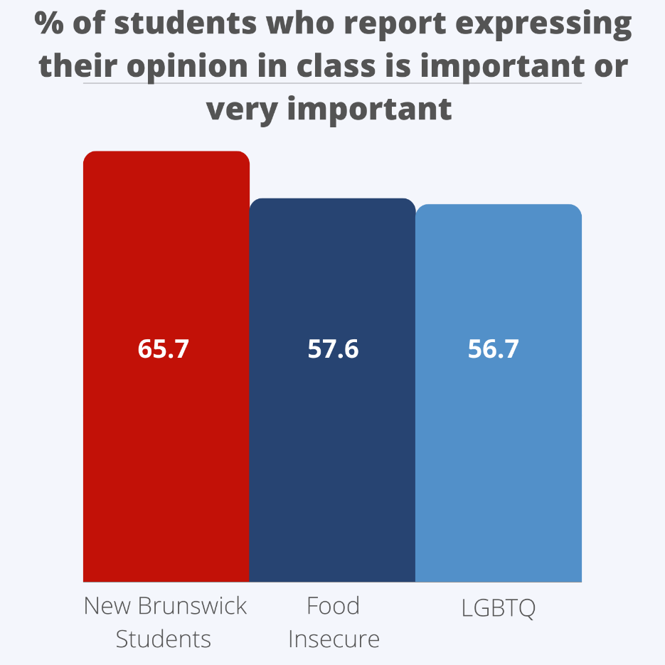
The data shows a slight increase in the percentages of students who report participating in activities or groups while in and out of school, with an rise of 5.3% and 4.1%, respectively, between 2015-2016 and 2018-2019. Students with special needs report a lower rate of the importance of expressing their opinion in class and getting involved in student council or similar groups – a difference of 4.4%. This indicates a lower level of social engagement among special needs students and could reflect a need to address barriers these students face to full engagement. They are also less likely to agree or strongly agree that there are good places to spend one’s free time. This could be indicative of issues surrounding accessibility.
Students who are immigrants report higher levels of engagement across several indicators but express a lower level of planning to vote when eligible.
Students experiencing food insecurity are 7.1% less likely than their peers to report that expressing their opinion in class is important to them and much less likely to agree there are good places to spend one’s time.
LGBTQ youth report a similar trend being 8% less likely than their peers to report that expressing their opinion in class is important to them and 6.9% less likely to agree there are good places to spend one’s time. They are also 3.2% less likely to indicate that involvement with student council or similar is important to them and 3.2% less likely than their peers to report participating in activities or groups outside of school.
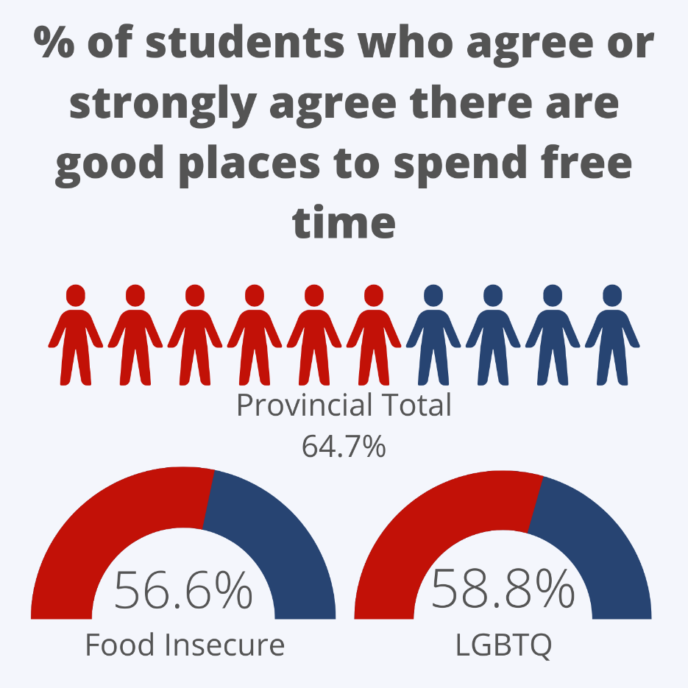
Regarding differences based on sex and gender, girls are 11% more likely than boys to plan to vote when eligible, 6.7% more likely to place importance on involvement in student council and similar groups, and 8% more likely to participate in activities or groups at school. Conversely, boys are 4.2% more likely to agree there are good places to spend one’s free time.
In terms of differences between language groups, Francophone children and youth are 7.8% less likely to place importance on student council but 6.6% more likely to participate in activities or groups outside of school than their Anglophone counterparts.
Thematic focus
As noted above, students with special needs report a lower rate of the importance of expressing their opinion in class. This is shared by students experiencing food insecurity and LGBTQ students. Students with special needs, students experiencing food insecurity, and LGBTQ students are also less likely to agree or strongly agree that there are good places to spend one’s free time.
Students with special needs report a lower rate of importance of getting involved in student council or similar groups. LGBTQ students also share this sentiment.
Given that these are all vulnerable groups who tend to experience several disadvantages, the overlap in these areas is particularly concerning and could indicate systemic barriers. Further, it should be noted that membership in these groups is not mutually exclusive. Membership in more than one of these groups could compound the indicators where multiple groups express a lower engagement rate.

What we need to keep an eye on
The indicators where there is overlap in lower levels of reporting from disadvantaged groups should be monitored. The overlap could be indicative of systemic or intersectional issues in these areas. In particular, the indicators of the percentage of students who report that expressing their opinion in class is important to them and the percentage of students who agree there are good places to spend one’s free time are areas of concern.
There are also several issues to be addressed with data available in this cluster. Efforts should be made to collect data to compensate for the unavailability of data due to the Covid-19 pandemic. Indicators that more closely align with individual enumerated rights within the UNCRC would give a clearer picture of how these rights are enjoyed in New Brunswick, as would having multiple indicators per right.

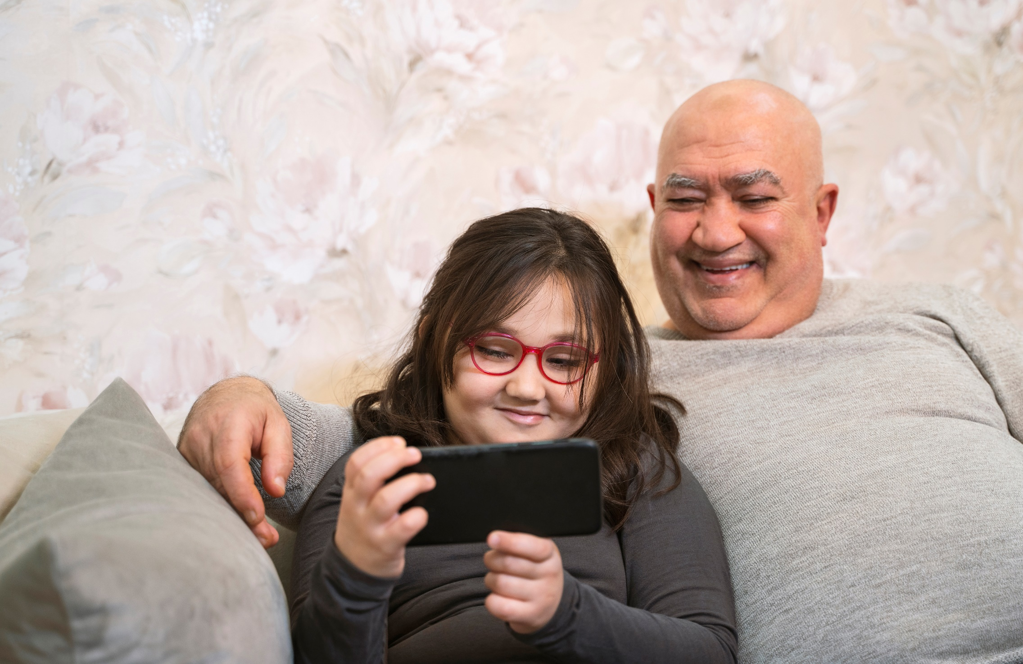
FAMILY ENVIRONMENT & ALTERNATIVE CARE

The preamble of the UN Convention on the Rights of the Child sets forth that the family is fundamental to children. “Recognizing that the child, for the full and harmonious development of his or her personality, should grow up in a family environment, in an atmosphere of happiness, love and understanding.” The Child Rights Indicator Framework groups the following rights into a cluster concerning the family environment and alternative care. In the CRC, article 5 concerns families providing their children with guidance appropriate for this age and development. Articles 9, 10 and 11 outline a child's rights concerning separation from parents and family reunification. Article 18 clarifies that the responsibilities of caring for a child are shared between the state and the family unit. Article 19 gives children protection from all forms of violence. Articles 20 and 21 concern children who are removed from their families temporarily or for the purposes of adoption. Article 25 is the right of a child in care to have that care periodically reviewed. Article 39 affirmed the right of rehabilitation and reintegrated for children exposed to mistreatment and violence.
Article 3 of the CRC outlines that government actors must consider the child's best interests. This was further expanded upon in general comment 14. General Comment 14 concerns the right of children to have their best interests taken into primary consideration. This can be applied as a rule of procedure for governments when they make a decision that generally impacts a specific child or all children. This encompasses the decisions made for children in alternative care arrangements outside their family environment.
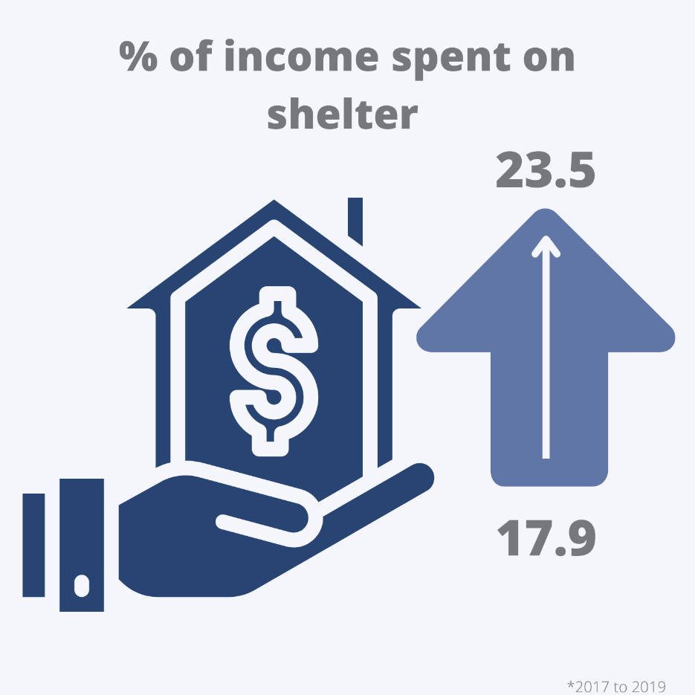
Data collection related to family and alternative care is shared between multiple government departments. For example, the research on household spending on food and shelter is collected and presented by the Federal government. On a provincial level, the Department of Social Development provides information on the number of families receiving social assistance, the number of adoptions, and the number of children receiving child protection and family enhancement services. The final data source is from the NB Health Council and the Wellness branch of the Department of Social Development, which conducts the middle and high school student wellness survey. The indicators in this survey focus on the youth’s relationship to their family with questions about how much their family knows about the youth and if the youth feel like their parents support them in difficult times. The available data in the CRIF is limited because the coronavirus pandemic impacted the ability to conduct updated assessments on a provincial level. Due to the lack of updated data sources, the indicators have not changed between the 2021 and 2022 reports.
The data from Statistics Canada on household spending shows a troubling trend. In the period between 2017 and 2019, the amount of money spent on food increased by over 5%. In 2022, Canada's Food Price Report predicted that the cost of food would increase by 5-7%. This increase will lead to higher family income spending on food. In the same period, the income spent on shelter rose from 17.9% to 23.5%. With significant investments in property in the province of New Brunswick, it can be inferred that the percentage of income spent on shelter has increased.
The number of children receiving child protection services per 1000 increased by 2.8% between 2020 and 2021. This increase represents over 350 children. In contrast, the number of children receiving family enhancement services has dropped. Family enhancement services (FES) are a collaborative approach provided alongside the child protection program. If an aspect of child development or security would be in danger without intervention, then the family would be referred to FES. In 2020, 543 children were receiving FES, but in 2021 only 13 were.
The Canadian Centre for Justice and Community Safety found that 405 children and youth are victims of family violence per 100,000 population. Data provided by the Department of Social Development reports that 26 youth under the age of 20 were involved in the child witness of family violence program in 2021. The comparison of this data illustrates a gap in services provided to youth. Hundreds of children in the province are not receiving support related to family violence.
In the area of family environment and alternative care, the CYA released a report "Through their eyes," which outlined the issues in the current child welfare legislation and its impact on children in the province. The report found that the rights of children in care under article 9 were being violated because they were frequently left out of the decision-making process concerning their care.
The provincial government introduced the Child and Youth Well-Being Act to improve child welfare legislation; this act replaces the Family Services Act. This bill was a recommendation from the CYA's review of the child welfare system in 2019. The government’s stated intention was to make the legislation more child-centric, but the act still has gaps. The content of the bill is currently being debated in the provincial legislature. The bill enshrines kinship care in law and provides a hierarchy of placement options for children in care, with group homes being the last resort. As a result of debates in the provincial legislature, the bill will be more focused on child rights and provide more mechanisms for data collection.
The dataset for this section does not provide enough information on children with disabilities to draw any conclusions. The data from social development is not disaggregated, which illustrates a gap in monitoring children with disabilities. There is limited desegregated data from the wellness surveys. In each category related to family environment, students with special needs were below average. For example, 53.6% of youth in grades 6-12 stated that their family would stick by them in difficult times, compared to only 44.6% for youth with special needs.
The development and debate of the Child and Youth Well-Being Act should be monitored. If passed, it should provide more research on children who interact with child protection services. More data must be provided from the wellness surveys because the situation of students has drastically changed with the coronavirus pandemic. The gap between children who experience family violence and those receiving services needs to be monitored. The list of issues from the committee's fifth and sixth reports of Canada on the rights of child ask that “measures be taken to develop a comprehensive national strategy to address all forms of violence against children.”

LGBTQ Data disaggregation
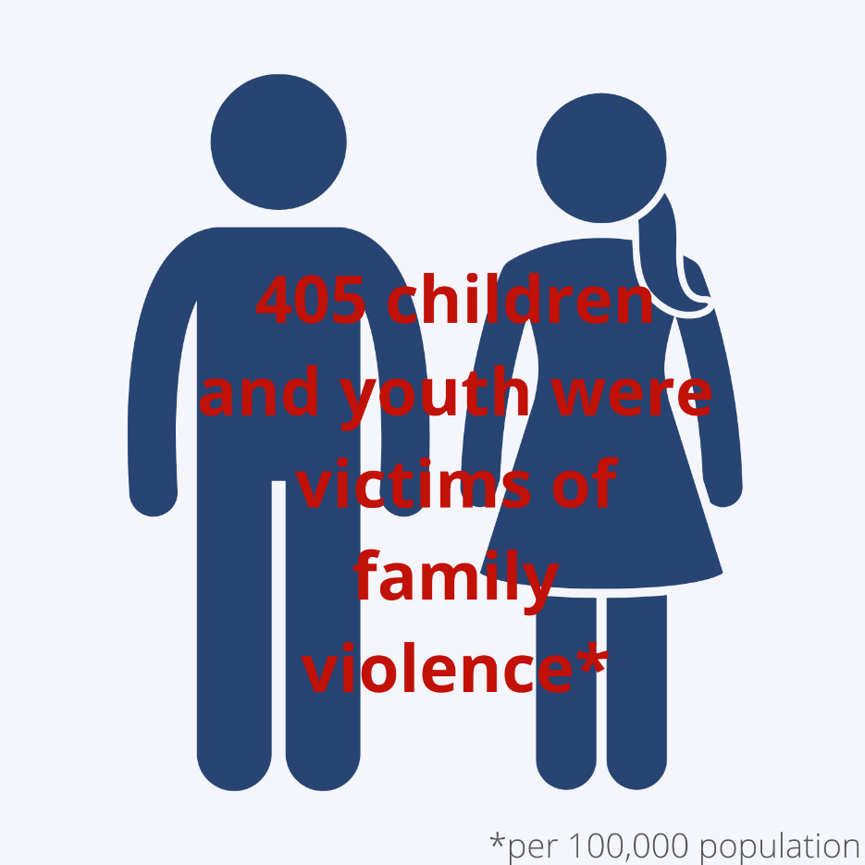
The intersectionality of LGBTQ and youth with disabilities shows that that population is at greater risk for discrimination. The number of students overall who report their health as being very good or excellent is 64%, compared to only 41.3% of LGTBQ students. The gap between the average and LGBTQ students could be explained by their higher than average rates of disability. 42.2% of LGBTQ students have special needs in education, nearly double the rate of 26.7 overall.
Based on the survey, 6.1% of students have a mental health disability, but for LGBTQ students, it is 15.8%. This troubling trend continues when the data is broken down by diagnosis. 37.7% of students in the province have anxiety, but 58.4% of LGBTQ students do. The depression rate for LGBTQ students is over 60% compared to only 37.6% of students in the province. 5% of LGBTQ students have autism, and 13.6% have ADHD. Only 17.6% of LGBTQ students feel like they belong in school, which is nearly 10% lower than the average.

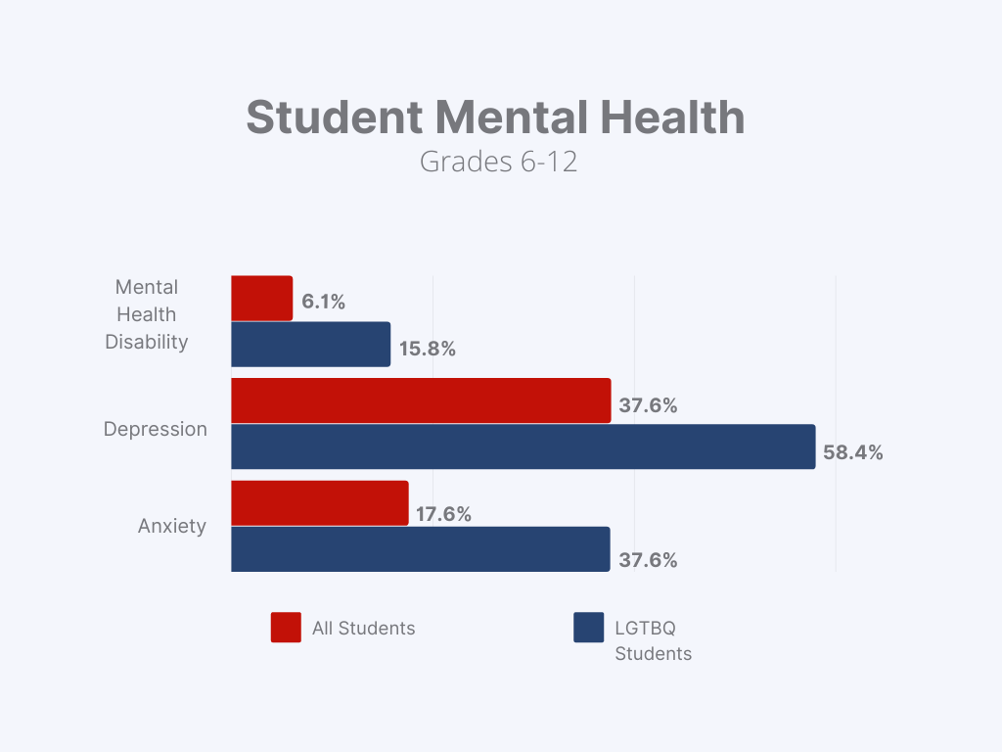

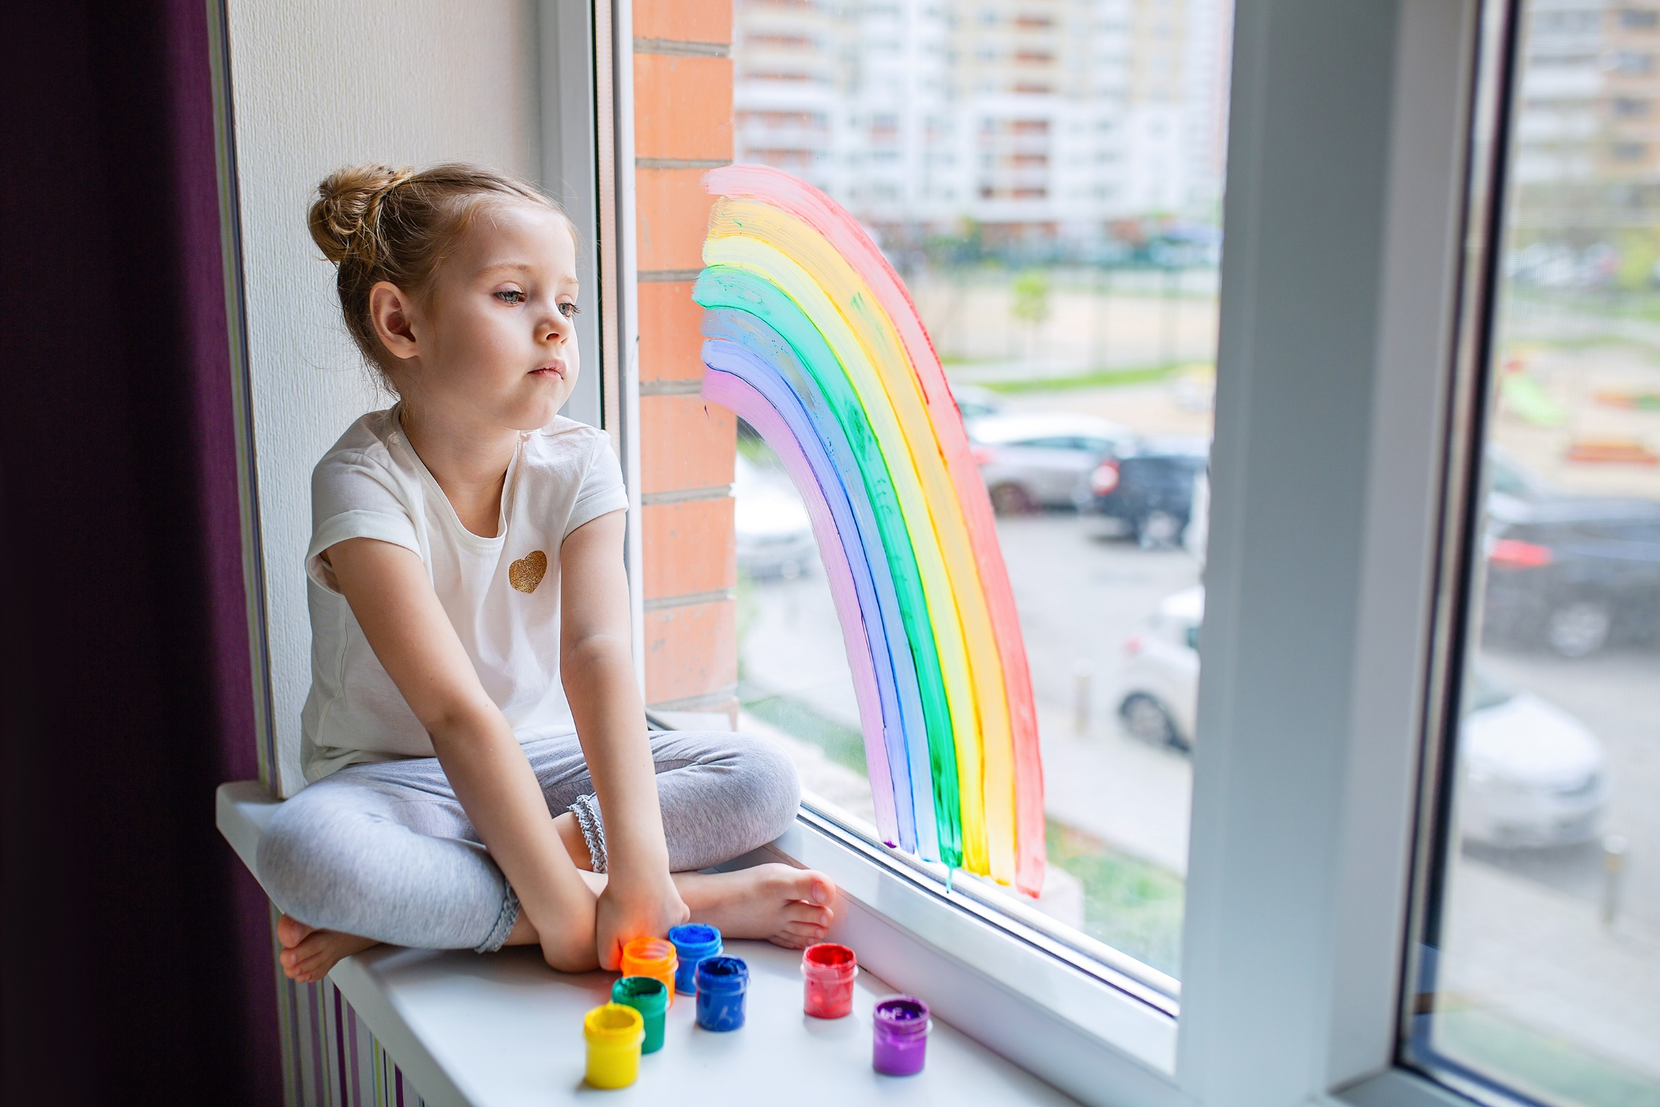
HEALTH & WELFARE

Every child in Canada is guaranteed the right to enjoy the highest standard of health possible. The CRIF report clusters six UNCRC Articles into one grouping, Basic Health and Welfare. Included in this cluster are Articles 6, 18, 23, 24. 26, and 27.
Article 6 of the UNCRC recognizes the child’s inherent right to life and requires advancing the child’s survival and development to the maximum extent possible. Article 18 recognizes the rights to be raised by their parents, where possible. This Article requires special consideration regarding child welfare and children who are removed from their families and placed in care.
Article 23 affirms the right to special education and care if a child or youth has a disability, which includes all of the rights in the Convention so that they can live a full life. Article 24 “imposes a strong duty of action” on all States who are party to the Convention to ensure that medical, health and all services related to them are available and accessible to children and youth. There is a particular onus and obligation towards under-served populations and areas.
Article 26 recognizes the right to social welfare assistance; it clearly affirms the right to help from the government if they are poor or in need. Article 27 affirms the right to have their basic needs met; this includes a right to food, clothing, and a safe place to live.

Indicators
The indicators in the CRIF are essentially statistical definitions of measure. They are designed to conform as well as possible to the measurement and selection criteria to produce reliable data. The CRIF includes both objective and subjective indicators. The objective indicators are those which would measure rates and counts of something (for example, the number of low-birth-weight babies). The subjective indicators require self-assessment or parental assessment of children’s and youth’s experiences in all facets of their lives. The indicators were selected to demonstrate the actual status of the surveyed children and parents. In the Health and Welfare section of the CRIF, all indicators are outcome-driven, namely showing the final impacts on the children and youth rather than assessing the programs that might have influenced those outcomes.
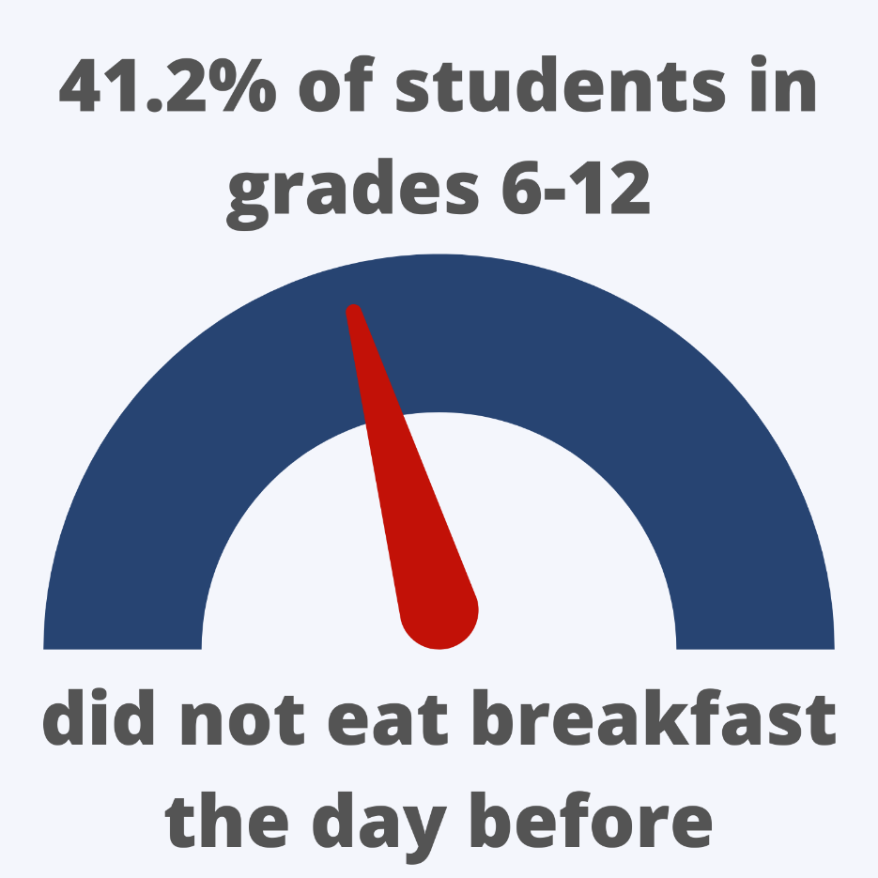

Overview of Data
The percentage of youth aged 12-17 indicating that they have a regular medical doctor is reported as being 93.7%, which is inconsistent with the provincial data regarding the accessibility of healthcare. In 2017 56% of people in New Brunswick did not have a family doctor, and the population has grown since that time exacerbating this problem. The number provided in the CRIF Report is inconsistent with other data available, and might be because of the way the question is worded, a child or youth may view seeing the same medical practitioner at a clinic as a “regular medical doctor”, the wording of the question leads to ambiguous and inconsistent results in this data set.
Concerning health care for newborns and infants, New Brunswick is trending upwards. 6% of children were born with low birth weight down from 6.2% in 2020, hearing increased from 91.3% in 2020 to 92.7% in 2021, which is also well below the national average of 6.9%.The percentage of newborns and infants screened for hearing increased from 91.3% in 2020 to 92.7% in 2021.
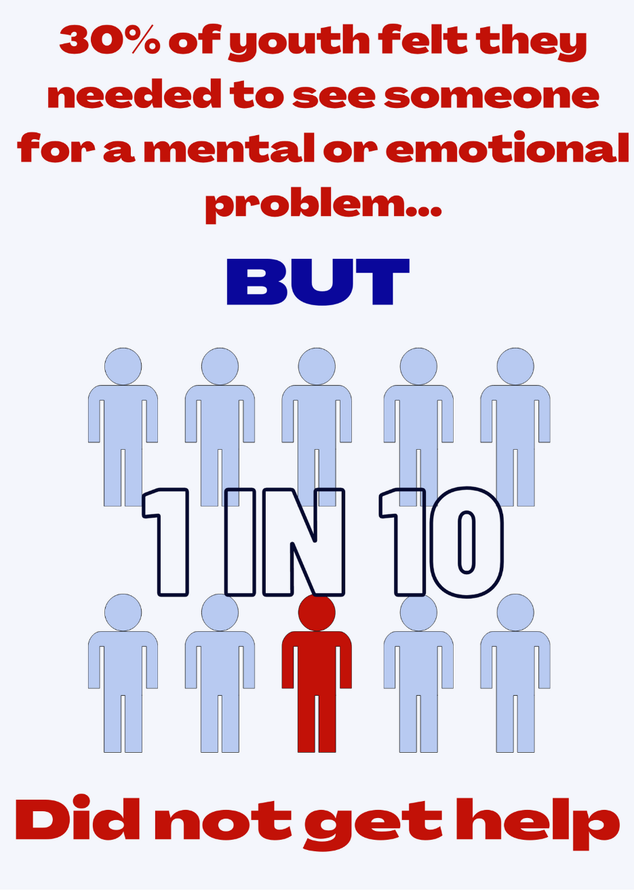
In 2021 the rate of children and youth hospitalized for injuries dropped from 27 in 2020 to 22.7. It is noteworthy that organized sports were unavailable to children and youth for the majority of 2021 and should be considered when viewing this statistic for significance.
The birth rate for teenagers in the province in 2021 declined to 8.6 per 10,000 from 10 in 2019; this is still significantly above the national average of 5.5 in 2020. The rate of youth with Chlamydia dropped from 1245.7 in 2019 to 863.2 in 2020. This is again a situation where the impacts of pandemic lockdown measures and restrictions should be considered when viewing these numbers.
The wait time for mental health treatment referrals declined to 53 days from 58 in 2020. Wait times vary around the province from 41 days in Health Zone 2 to

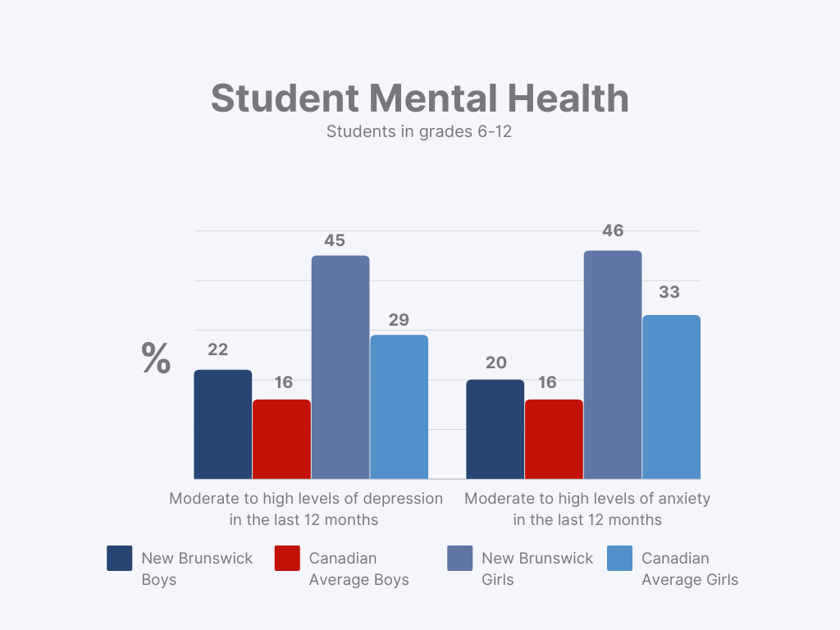
95 days in Health Zone 4. Close to 30% of youth report feeling they needed to see someone to address a mental or emotional problem, yet 1 in 10 of them did not. This represents address a mental or emotional problem, approximately 3,900 New Brunswick youth who needed mental health help whose needs were not met for various reasons. As per the UN General Comments, “[s]tates have the obligation to provide adequate treatment and rehabilitation to children with mental health and psychosocial disorders”, New Brunswick is not fulfilling this obligation.
In 2021 the rate of hospitalized cases for mental diseases and disorders was 9.3 per 10,000, down from 11.3 in 2020 and much below the national average of 31.5. However, in 2021 the number of in-patient beds in provincial mental health facilities was decreased by 40%. Without considering this decrease in services available to children and youth struggling with serious mental illness, viewing this decrease as an actual decrease would potentially yield a false sense of improvement.
The rate of childhood/adolescent behavioural and learning disorders admitted to hospital in 2020 fell to 9.3 from 11 in 2019; while a negative trend would appear to be a good thing, this is still more than double the national average of 4.0. The rate of children and youth admitted to hospital for stress reaction/adjustment disorder is down to 8.1 from 8.4, which is still far higher than the Canadian average of 5.6. The rate of children and youth admitted to hospital with a mood affective disorder is up to 2.0 from 1.5 in 2020; this is 2.5 times the Canadian average of 0.8.
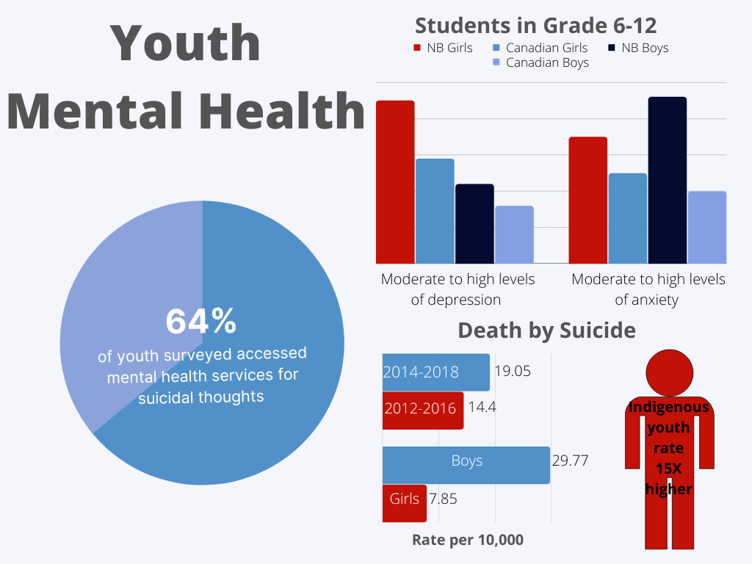
Anxiety and depression, both diagnosed and undiagnosed, are of significant concern when it comes to New Brunswick youth. The rate of children and youth hospitalized for depressive episodes in 2020 was 9.7; while this is down from the 2019 number of 11, it is still much higher than the Canadian average of 7.8. Students were asked in the OURSchool surveys to self-report their assessment of their levels of depression in the preceding 12 months. 36% of students in grades 6-12 had moderate to high levels of depression (the Canadian norm for this age group is 23%). When broken down by gender, 45% of the girls and 22% of the boys had moderate to high levels of depression, the Canadian average for the same age group is 29% and 16%, respectively. The rates of admission for child and youth anxiety disorder were 3.3 in 2021, up from 3.0 in 2020. In the OURSchool survey, 35% of students in grades 6-12 self-reported having moderate to high levels of anxiety; the Canadian norm in this age bracket is 25%. 46% of girls and 20% of boys self-reported having moderate to high levels of anxiety; the Canadian norm is 33% and 16%, respectively. Indigenous youth were 20-25% more likely to experience symptoms of depression than their counterparts.
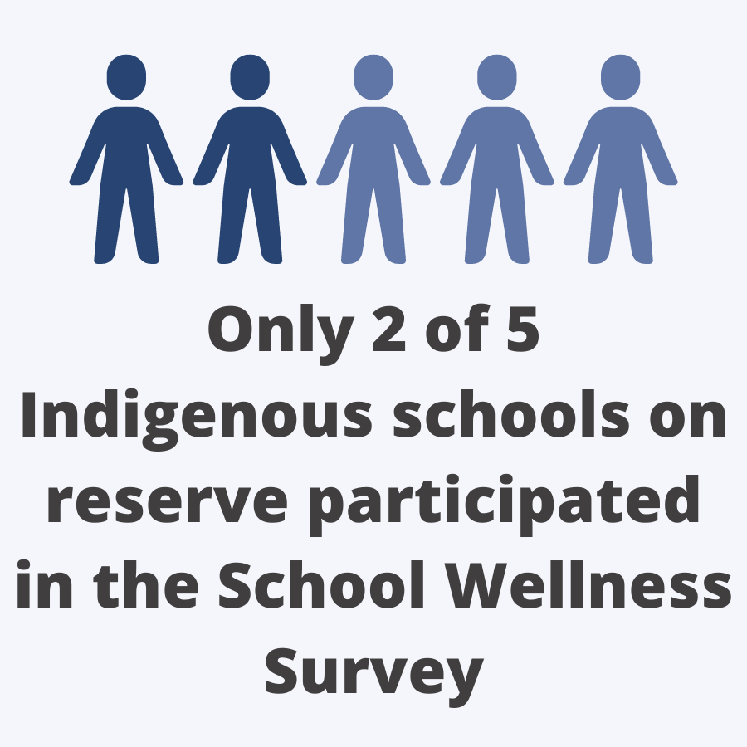
The numbers are alarming when regarding the rate of premature death due to suicide. From 2014-2018, the rate was 19.05 per 10,000, up from 14.4 in 2012-2016. Even more troubling is that the rate of male youth committing suicide was 29.77 per 10,000 versus the female rate of 7.85. The numbers presented in the OURSchool surveys show that the boys reported a lower incidence of moderate to severe/high anxiety and depression symptoms in the last year. When assessing the CRIF data for hospitalizations for all but behavioural/learning disorders, the boys’ rate was always lower than the girls’. We must look to see what is causing our male youth not to seek help, not to report mental health concerns, ultimately lead to so many of them taking their own lives. We are failing them; they are falling through the cracks of the system. Indigenous youth have suicide rates 15 times those of their counterparts. In the surveys conducted by the Child and Youth Advocate’s Office in 2021, 64% of youth surveyed access mental health services due to suicidal thoughts. These numbers are troubling and must be addressed to fulfill our obligations under Article 6 of the UNCRC.
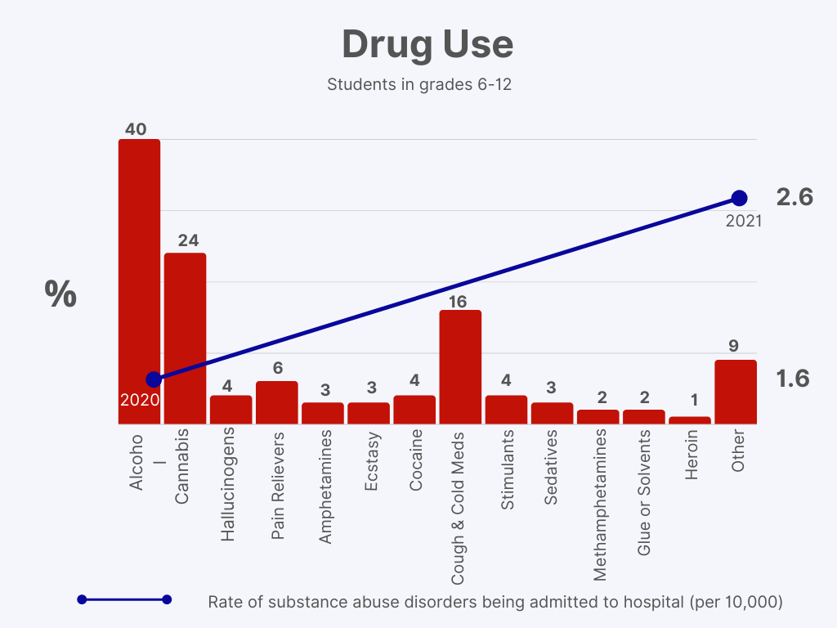
The rate of children and youth admitted to hospitals for eating disorders was 1.5 in 2021, up more than 100% from 0.7 in 2020. However, it still falls short of the national average of 2.5. This would lead one to question the root cause of these eating disorders. Could this potentially be linked to body positivity and bullying? The CRIF report provided that 41.2% of students in grades 6-12 did not eat breakfast the day before, which is not as indicative of food insecurity as it appears. When broken down by reason breakfast was not consumed, only 4% of students reported not eating breakfast, so 9.7% overall responded that they did not eat breakfast due to not having food available. More students, 6% of those who reported not eating breakfast or 14.6% overall, reported that they did not eat breakfast because they were trying to lose weight. The UN System Standing Committee on Nutrition recommended that “[s]chool feeding is desirable to ensure all pupils have access to a full meal every day, which can also enhance children’s attention for learning and increase school enrolment.”
The rate of substance abuse disorders admitted to hospitals in 2021 was 2.6, up from 1.6 in 2020, and higher than the national average of 2.0. The School Wellness Survey includes alcohol use (40%), cannabis use (24%), LSD and other hallucinogens (4%), pain relievers (6%), amphetamines (3%), ecstasy (3%), cocaine (4%), cough and cold medicines (16%), stimulants (4%), sedatives (3%), methamphetamines (2%), glue or solvents (2%), heroin (1%), and other drugs (9%).

What We Need to Keep an Eye On
The Covid-19 pandemic has wrought havoc on the lives of adults and youth alike. We currently do not have the data available to see what specific impacts it has had. We need to watch for declining mental health trends during the pandemic’s lockdowns and restrictions and keep a keen eye as to whether they rebound following the lifting of the restrictions. As a province, compared to the national average, we are failing our youth, given the numbers relating to mental health and illness. Even more concerning is the prevalence of suicide reported amongst our male population under 20.
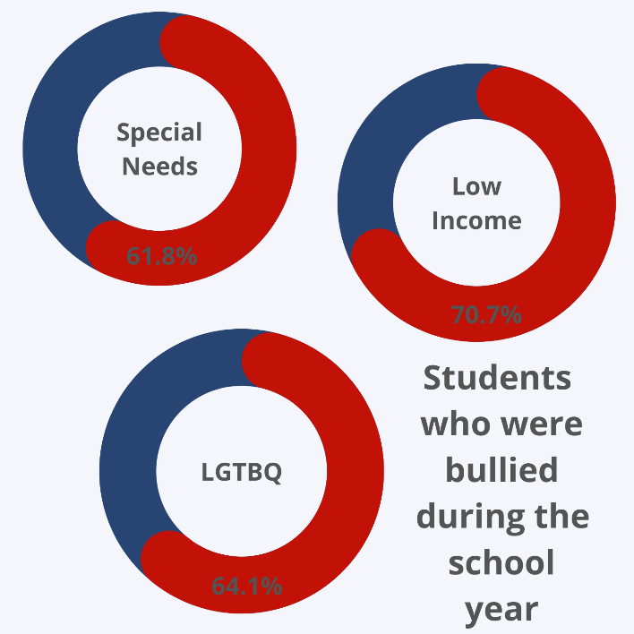
We need to monitor and assess the impact of bullying on New Brunswick youth. Based on the statistics, bullying was identified in a CBC article as needing to be a National Emergency. Yet, we are not tracking this issue regarding children and youth’s health and well-being. Widespread bullying in schools was also identified by the UN Committee on the Rights of the Child in their Concluding Observations following their review of the combined third and fourth periodic report from Canada.
The CRIF report provides some statistics based on special needs and identifying as indigenous. Still, it does not define what would constitute a special needs student. Without this definition, comparison with the rest of Canada is inappropriate as we are not certain we are comparing like scenarios. 18% of students in the province are identified as having a disability, yet 27% reported a learning exceptionality or special education needs in 2019 on the Student Wellness Survey. This inconsistency in what constitutes “special needs” or a “disability” will need to be addressed if we hope to identify the fundamental factors impacting the health and wellbeing of the children with disabilities in New Brunswick.
More effort must be made in data collection regarding indigenous children. The 2019 School Wellness Survey indicated that 2 of 5 indigenous schools on reserve participated in the survey. Still, their answers would only be reported in their school reports. Indigenous children on reserve deserve the same rights afforded to all children off of reserve. Their survey answers should be reported with the general population rather than hidden from view.
We must also track the accessibility of mental health services to youth in the province. 2021 already saw a decrease of 40% of available in-patient beds in the hospital setting for youth mental health patients; add to this decrease, the stalling of the Center of Excellence and access to treatment may prove challenging.

Legislative or Policy Development and Best Practices
Creating and implementing policies which would increase access to mental health support for children and youth will be paramount in addressing the dire numbers the CRIF presented. Alongside this is the need for educational school programs to teach students more about themselves, their health and mental well-being, and the available resources.
Focusing on our male youth, we need to determine what is causing the disproportionate number of suicides. Once this has been identified, policies will need to be created to address this situation and provide support to these youth in crisis.
Indigenous students’ survey results should be included with the surveys from the general population of students in the province. Keeping their responses separate merely skews the data and prevents them from having access to equal opportunities and services as it is not brought to attention if there are any discrepancies. These youth deserve to be treated equally to their peers, not segregated.
An inclusive “working definition” of special needs/disabilities needs to be determined so that statistics can be appropriately compared. It will be impossible to adequately determine the current state of children and youth with disabilities until we can affirm that we are gathering comparable data to other jurisdictions.

EDUCATION, LEISURE & CULTURAL ACTIVITIES

Access to quality education is a fundamental part of children’s physical, mental, and social development. It provides an opportunity for youths to develop not only intellectually but also provides a medium for social and emotional growth, which form the foundation for developing effective life skills. All children must be awarded an equal opportunity to develop and succeed under an education system that respects and promotes their rights and aims to provide the highest attainable standards for facilitating that learning.
The United Nations Convention on the Rights of the Child (UNCRC) addresses the right to education. It provides guidance and authority for how state parties should interpret this right. Articles 28 and 29 highlight children’s right to education, including an education that promotes and fosters growth and the development of youth’s physical and mental abilities to their fullest potential.
Article 28 outlines that state parties “recognize the right of the child to education, and with a view to achieving this right progressively and on the basis of equal opportunity…”. Additionally, the article outlines particular actions that state parties should undertake to ensure they are implementing policies that align with the rights and framework outlined in article 28.
A child’s right to education is not simply a right to access or receive an education but also applies to the content of that education. Article 29 provides a qualitative element to the right to education that is established in article 28 but also encourages the development of child-centered, child-friendly and empowering education strategies and systems.^{[iv]} Every child has the right to an education system that helps them develop life skills, and aims to strengthen the child’s capacity “to enjoy the full range of human rights and to promote a culture which is infused by appropriate human rights values.”^{[v]} The goal of this approach is to create an environment which fosters not only traditional learning but creates a system that empowers children to develop in a way that allows them to live “a full and satisfying life within society.” Educational plans and curriculums must go beyond the traditional subjects like math, sciences and literacy and need to incorporate the teaching of essential life skills so that no child leaves school without the skills needed to face everyday challenges in adulthood, to be able to make reasonable and well-balanced decisions.
Article 31 establishes children’s right to rest, leisure, and participate in cultural and creative activities. Furthermore, this right should be promoted and supported by state parties. There are many benefits associated with rest and leisure activities, including but not limited to, the development of creativity, self-confidence, imagination, self-efficacy, emotional skills, fine motor skills, and cognitive skills.

Indicators
Measuring the effectiveness of education systems within New Brunswick is a challenging task. Children have individual needs, and a strategy that may be effective for most is not effective for all. The Child Rights Impact Framework (CRIF) aims to provide a snapshot of the status of the education system through data collection and analysis. This data forms indicators which are used to assess and monitor the promotion and implementation of human rights, such as the UNCRC but are also used as a justification for implementing policy changes over the short and long term. The Education, Leisure and Cultural Activities section of the CRIF captures data related to the rights enumerated in articles 28, 29, and 31 of the UNCRC.
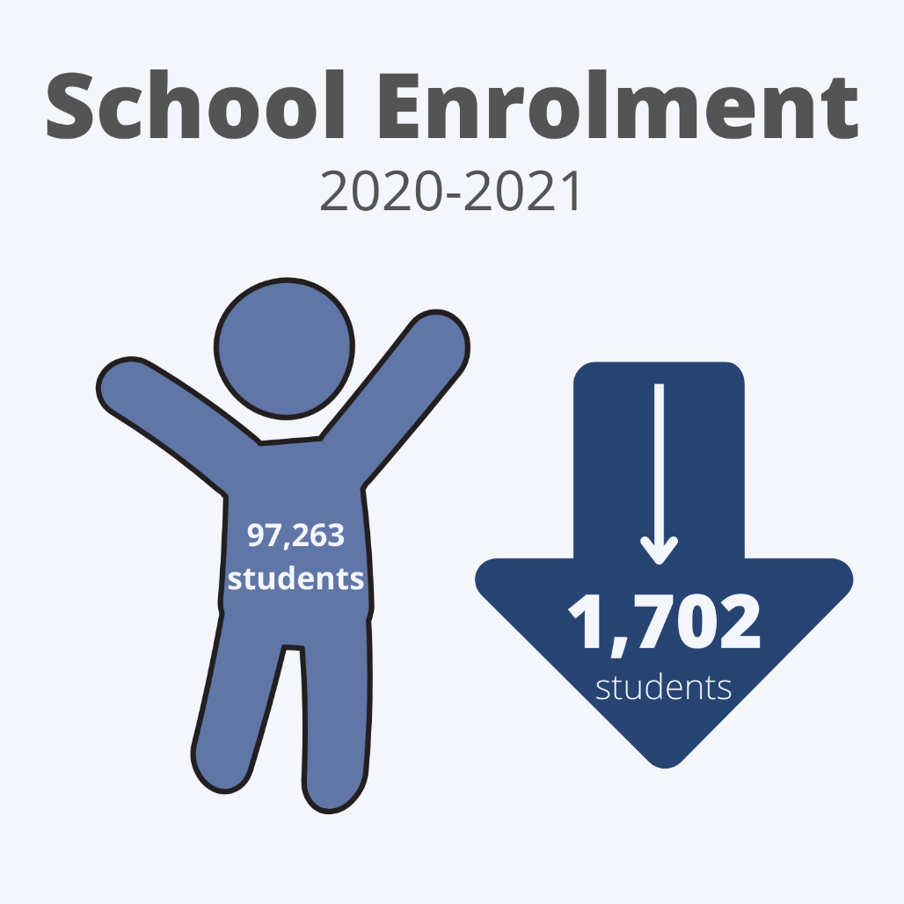
Process indicators provide insight into the functioning of institutions. They also measure state parties’ efforts to transform their human rights commitments into the desired results, such as the Department of Education’s effort to promote and respect children’s rights under the UNCRC. The indicators evaluate the policies in place and measures taken by the duty bearer. Process indicators related to education include the number of children and youth enrolled in school.
Alternatively, outcome indicators demonstrate individual and collective attainments that reflect children’s enjoyment of their human rights within a given context.. In the context of the education system, these include the percentage of grade 12 students who feel respected at school; the percentage of students who had opportunities in high school to participate in elective courses they were interested in; the percentage of students who participate in physical activities organized by their school; and the percentage of grade 12 students who participate in physical activities not organized by their school. Almost all the indicators in the Education, Leisure and Cultural Activities section of the CRIF are outcome-driven.

Overview of the data
As a result of the measures taken in response to the COVID-19 pandemic, like moving to online learning, the standard mechanisms for collecting data were disrupted. Hence, there is a significant gap in the data collected this year by Education and Early Childhood Development. Nevertheless, some of the indicators have fluctuated significantly compared to previous years and are worth discussing.
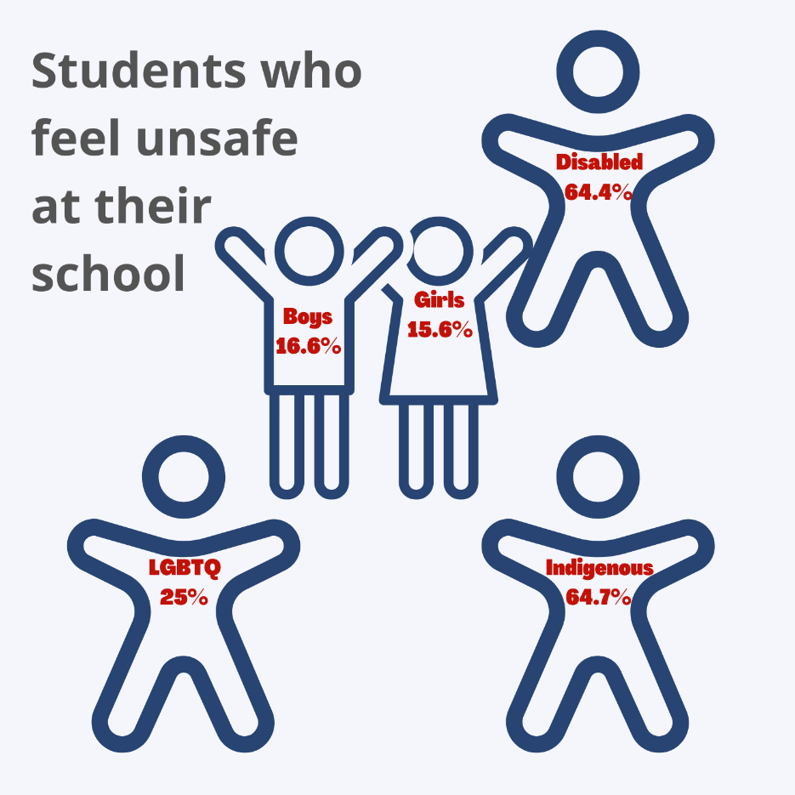
The health crisis has disrupted the lives of youths in countless ways. It has impacted their education, development, mental and physical health, social life, and much more. The impacts will be long-lasting and observable for years to come. For some youths, school provides a place of solace, where they can access mental health services, nutritious meals, and socialize with friends and staff. With school closures and the move to online schooling for a period of the school year, young people in an important developmental period lost their routine and support system. School closures have undeniably impacted educational as well as non-educational aspects of children’s development.
During the 2020-2021 school year, there were 97,263 youths enrolled in school, a decrease of 1,702 students from the previous school year. The enrollment reduction is mainly observed in the kindergarten to grade five student population and the anglophone school district. Although it is unclear what factors can account for the declining enrollment figures, the pandemic is presumably a significant cause. Some parents may have decided to home-school their children or defer starting kindergarten for a year. Other families may have had health issues or concerns or remained unvaccinated.
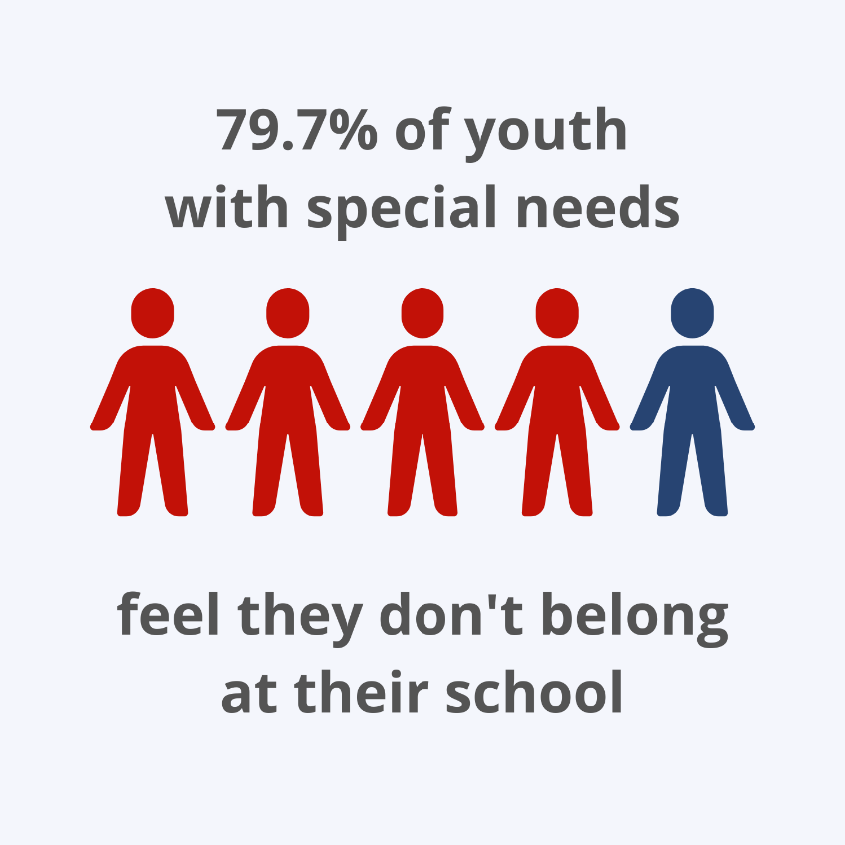
A cohort of youths at an increased risk of vulnerability must be monitored closely to ensure that their needs are being met and rights being protected are youths with special needs. Children with disabilities face discrimination and stigmatization and are often excluded from mainstream society. The following quote perfectly illustrates the need to continually promote and respect the rights of children with disabilities: “the barrier is not the disability itself but rather a combination of social, cultural, attitudinal and physical obstacles which children with disabilities encounter in their daily lives…”
Children with special needs have the same right to education as the other students, enshrined in the Convention on the Rights of Persons with Disabilities. Persons with disabilities include those who have “long-term physical, mental, intellectual, or sensory impairments which in interaction with various barriers may hinder their full and effective participation in society on an equal basis with others.”
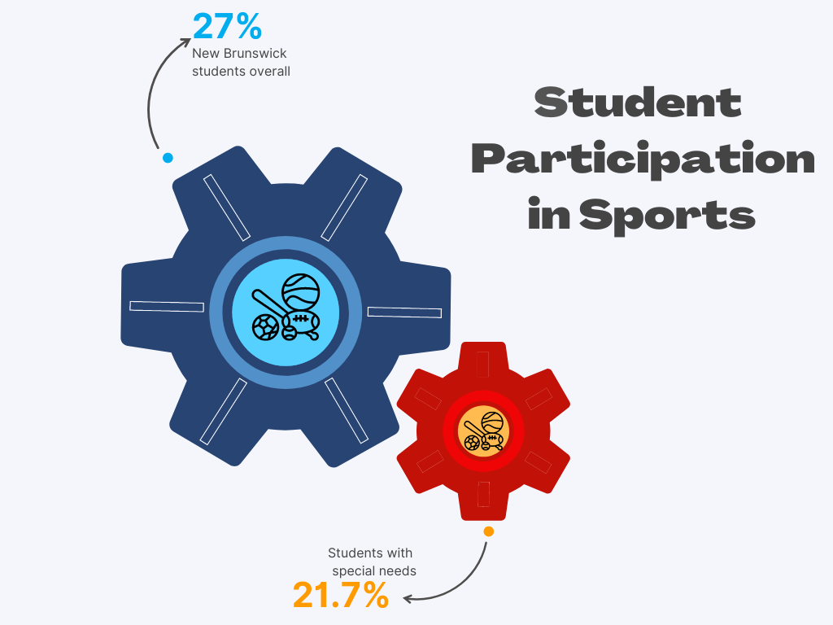
Only 20.3% of youth (grade 6-12) with special needs reported they felt they belonged at their school. The right to education includes a safe learning environment free from discrimination. Discrimination based on a disability “offends the human dignity of the child and is capable of undermining or even destroying the capacity of the child to benefit from educational opportunities.” Youth with special needs undeniably face discrimination at school, leading to their marginalization and exclusion, making 79.7% of them feel like they do not belong at their school.
Furthermore, only 34.3% of students (grade 6-12) with special needs reported having opportunities to develop skills that would be useful later in life. Education should be provide youth with life skills that will help them confront challenges and make difficult decisions later in life. The education system is failing to provide youths with disabilities with effective life skills. The schools’ educational plans should be tailored toward the needs of these children while ensuring that they are not excluded from the general education system.
Only 21.7% of youth with special needs and 27% of students overall reported participating in a sports team within school. Being part of a sports team or a group activity is essential for a child’s sense of belonging. Additionally, activity is vital for a youth’s mental and physical well-being, especially during times of crisis like a global pandemic. Although COVID-19 has halted many activities for health and safety concerns, it is crucial to resume sport activities for their therapeutic benefit.

Legislative or Policy Development and Best Practices
Recruitment and retention of psychologists within the school system is an ongoing struggle for New Brunswickers. Our Office’s review of Youth Suicide Prevention and Mental Health Services in New Brunswick shows a chronic shortage of psychologists within the school system. Recent changes in legislation through Bill 35 amended the Education Act.
The amendments to the Education Act allow teachers with a Master’s degree approved by the Minister to receive additional training to carry out some testing that was previously done exclusively by psychologists. Access to mental health support at school is essential for children and youth, especially during a health crisis. Bill 35 aims to reduce the workload of psychologists within the school system. Hopefully, these legislative changes will free up more time for psychologists to provide easy access to mental health services to youth promptly. While this law reform was greeted with dismay by the College of Psychologists and some families of children with disabilities and their allies, it does, in our view, represent an opportunity to facilitate greater access to clinical services that are in short supply.
One way of ensuring that the child’s right to access health and educational services is balanced with a commitment to quality care and adherence to accepted standards of professional health care is to ground these services upon a robust commitment to child rights as defined in the UN Convention on the Rights of the Child. The jurisprudence and the guidance available from the Committee on the Rights of the Child outlines how best to balance these competing rights for all State Parties. The Department of Education and Early Childhood, as the lead Department in the implementation of Integrated service delivery, could make amendments to the Education Act to incorporate the UN Convention on the Rights of the Child into New Brunswick law by direct reference. The rights of the child must be promoted and respected first and foremost by educators themselves and in the schools and classrooms where children find themselves. The first step to ensuring that they are is to incorporate the UNCRC in the Education Act.

What We Need to Keep an Eye on:
The covid-19 pandemic will have far-reaching impacts related to missed time, sub-optimal learning environments, and mental health problems resulting from lengthy periods of social isolation. New Brunswick’s school system needs to be prepared to respond to what will likely be an increase in demand for services. Youth may require increased access to mental health services as they process the social and emotional impacts of the interruption to their schooling. Through our Office’s advocacy, we have seen an increase in children missing significant periods of school. Traditional support systems have also been interrupted because of the pandemic, with many families having to adapt to delays in services from departments. Service providers must be prepared to address these issues and work with children, youth, and their families.
Children having the opportunity to engage in recreational and leisure activities is essential for their physical and mental health and an important social opportunity. Activities such as organized sports or clubs allow for children to socialize, exercise and develop healthy life habits. During the pandemic, finding ways to organize opportunities for children and youth to play, while following public health guidelines has been challenging. As New Brunswickers continue to deal with restrictions and challenges related to the pandemic, education systems must commit to finding safe spaces that allow children to exercise their right to play providing them with time to allow for creative exploration and physical activity.

SPECIAL PROTECTION MEASURES

Special protection measures are those measures taken to shield children and youth from dangerous situations. This can include measures taken in emergencies, such as war or armed conflict. It can also include prevention measures, such as ensuring that children and youth are not exploited by adults in the workforce or when in contact with the criminal justice system. The UNCRC provides special protections regarding the ability to practice culture and language, which is especially important given how these rights have historically been restricted for Indigenous children in systems of state care. Likewise, children and youth whose liberties have been restricted are provided special protection under the UNCRC. Young people who have been institutionalized are particularly at risk of having their liberties impeded by unjust infringement. Accordingly, all criminal justice professionals and processes must respect a child or youth’s rights throughout the system.
General comment 24 by the UN Committee on the Rights of the Child features special guidance for interpreting UNCRC rights affected by the criminal justice system, with diversion away from the criminal justice system the clear preferred approach for children accused of an offence. That said, even diversion should only be used when “there is compelling evidence that the child committed the alleged offence.” General Comment 24 provides a clear interpretation of the UNCRC and asserts that deference should be given to the rights of the child wherever possible. In some circumstances, minimal infringement of the child’s rights may be necessary for the protection of the public, however, no child should ever be deprived of their rights arbitrarily. Domestically, the Youth Criminal Justice Act (YCJA) echoes this directive, stating that youth must be treated differently than adults in the criminal justice system due to their diminished moral blameworthiness and capacity. When dealing with youth, there should be an emphasis on rehabilitation and reintegration, fair and proportionate accountability, enhanced procedural protections, timely intervention, and prompt enforcement of the act.
Notably, General Comment 24 discusses the capacity of youth and children. States should devise minimum ages of criminality, and all states should consider all circumstances of the child in determining the appropriate action in response to criminality. All factors, including the child’s age and mental health, should be assessed to determining a proportionate response. Children who suffer developmental/neurodevelopmental disorders, delays, or disabilities should be excluded from the child justice system entirely.
The enjoyment of all rights subject to special measures are assessed in the Child Rights Indicator Framework (CRIF). The CRIF presents data regarding the number of youth sentenced to open or secure custody, the number of multidisciplinary conferences held, and the number of youth in extra-judicial measures (EJM) programs, among other criminal justice indicators. Additionally, the CRIF displays the number of families receiving subsidies for adopted children with special needs and the number of families receiving support for children with disabilities. The data for all of these special measures categories is provided in terms of total numbers for the year and is not categorized further to inform, for instance, how many children with special needs have been involved in the criminal justice system in the previous year. Some CRIF Special Measures data that is ordinarily broken down by group – such as indicators regarding substance use – is unavailable for the 2020-2021 year.
New Brunswick has made significant improvements to the youth criminal justice system over the past five years. A particular accomplishment is the consistently low number of youth in secure custody at NBYC. The Department of Justice and Public Safety has also indicated an interest in moving towards a child rights-friendly justice system. The Committee on the Rights of the Child noted in General Comment 24 that countries with child-friendly justice have been noted to lower the rate of youth in the criminal justice system.
Another recent development which will impact youth in the criminal justice system is the working group currently in progress to develop restorative justice practices in New Brunswick. Restorative justice is a non-adversarial harm-reparation approach to justice which brings together the people who have been affected and focuses on the healing of the victim, accountability of the offender, and identifying needs and root causes of crime. One of the applications of restorative justice is to divert youth from the traditional criminal justice system process; however, it can also be used in education and group home settings. This process would provide a useful, prompt, and collaborative method to resolve disputes and direct youth to services which may be more beneficial for resolving the problems they are experiencing.
Regarding the CRIF data, the unexpected decrease in multidisciplinary conferences and EJM should be further explored. These two processes help to achieve the goals of the YCJA and UNCRC. EJM are presumed adequate and should be used to hold the young person accountable (YCJA 4(c-d). If EJM is being used less and the crime rate has not decreased, it should be determined what processes youth are undergoing and ensure this aligns with the child and youth rights identified in the UNCRC.
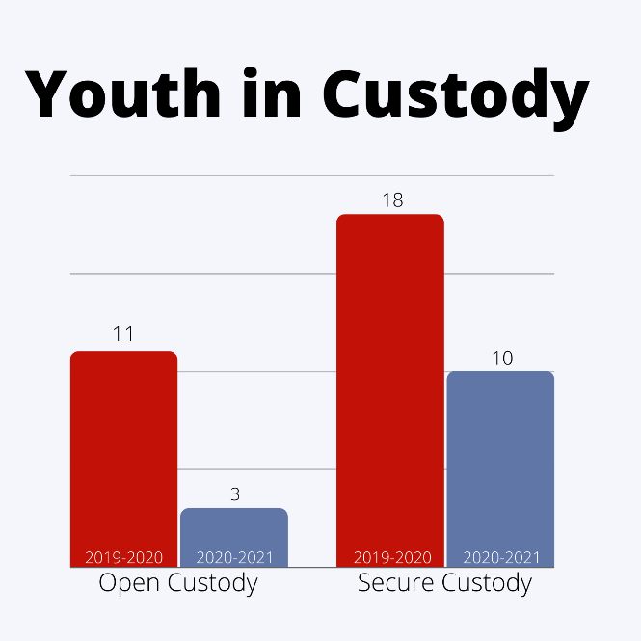
The reason for this downward trend is unknown. It could represent fewer referrals to EJM or reflect fewer youth involved in the criminal justice system. The significant decrease in the number of youth in open custody (3 in 2020-2021 as compared to 11 in 2019-2020) and secure custody (10 in 2020-2021 as compared to 18 in 2019- 2020) in New Brunswick, however, suggests that youth are not instead being subject to more punitive measures. Disaggregation of this data is not available to provide a complete understanding of the downward trends and whether these decreases are seen equally across different population demographics.
The data for the number of children and youth with exceptionalities involved in the criminal justice system is not included in the CRIF. That said, the Office of the Advocate is aware of several instances where children and youth with such disorders and delays made contact with the courts in a youth criminal justice context. General Comment 24 is unequivocal in its abhorrence of such practices. Similarly, a critical issue which was brought to our attention while writing “The Best We Have To Offer” is ensuring that youth with mental health needs are not criminalized. The YCJA expressly states that “a youth justice court shall not use custody as a substitute for appropriate child protection mental health or other social measures” As noted above, this is similarly stated concerning children and youth with exceptionalities in the UNCRC. This portion of the UNCRC (and indeed, the YCJA) is not strictly upheld in New Brunswick. Based on these observations, it is clear that the youth criminal justice system is not presently equipped to engage with mentally ill or neurodelayed/disabled young people.

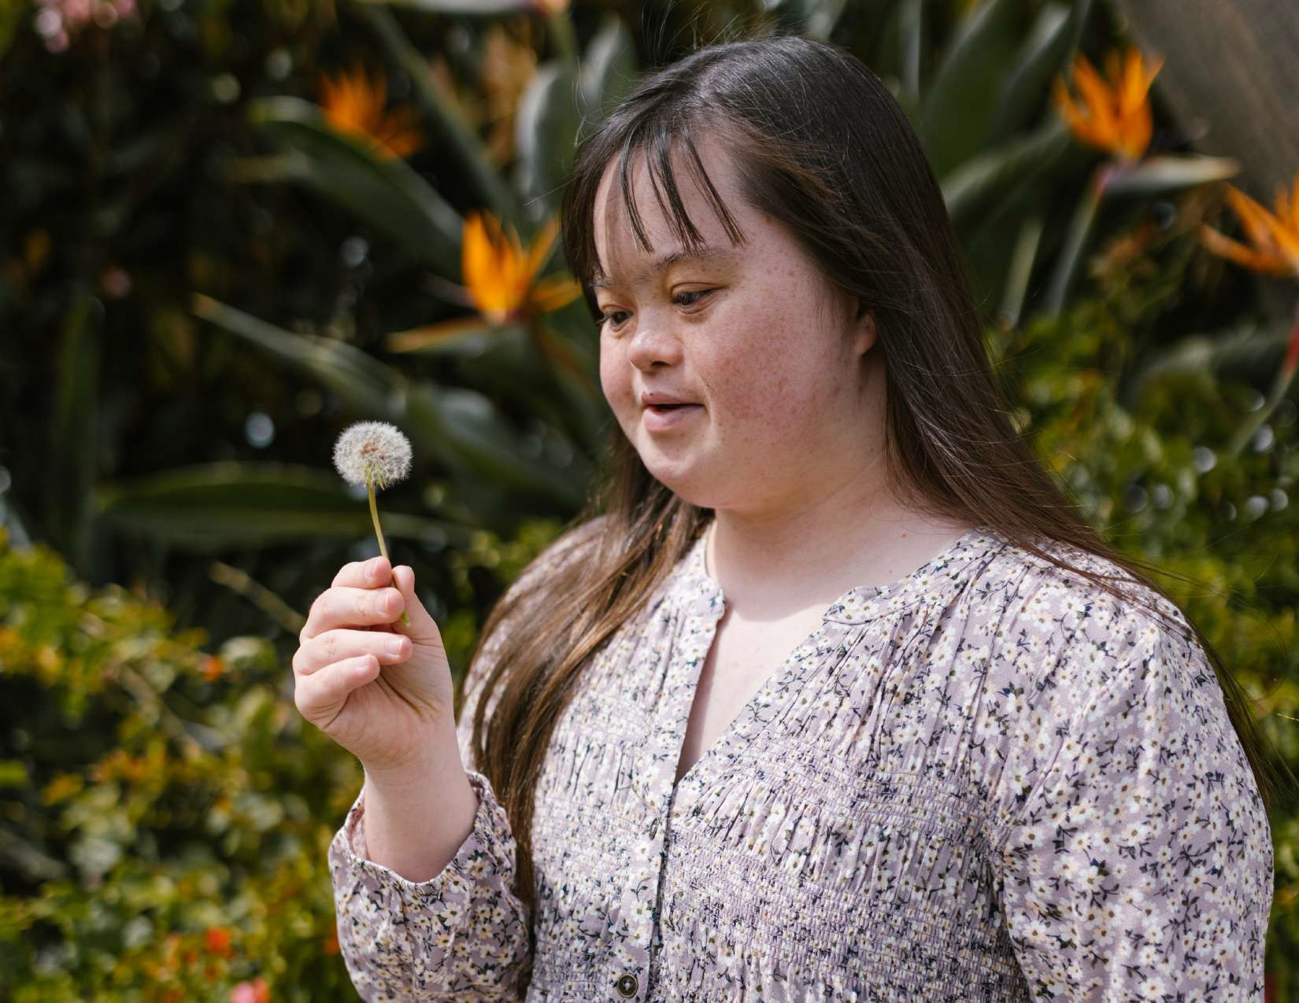

CONCLUSION

Looking at the needs of children in 2022, it is clear that we will need, moving forward, to apply a very intentional focus on special measures to assist young people in transitioning past the pandemic. As one participant in a recent UNICEF youth panel in which we took part stated: "We are living the best years of our lives in the worst of times." This can impact how youth feel about their futures, their readiness to pursue post-secondary studies and where they may choose to study, or their ability to transition effectively into the labour market. Children and youth with disabilities have had a particularly challenging time through the pandemic, sometimes being required to take extra measures to isolate and avoid infection because of a compromised health condition, sometimes missing out on essential health care services because of service restrictions through the pandemic, sometimes feeling the added pinch of labour market conditions affecting their families and careers. These are all circumstances where governments must provide added services to ensure an equal playing field. Yet, our pandemic responses have not always considered the particular needs of children with disabilities or other vulnerable populations of children. In fact, we have not generally paid sufficient attention to the pandemic impacts on children. 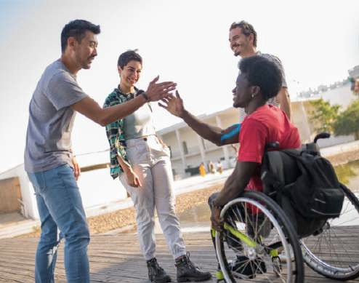
The recommendations outlined above are a starting point from which New Brunswick leaders can begin to correct these equity gaps. The Advocate's Office will be following up with the government to track their acceptance and follow through on these recommendations using our new recommendation monitoring process. This report is being launched at the 11th edition of the International Summer Course on the Rights of the Child, which explores the challenges in implementing the rights of children with disabilities. As Advocates, we commit to working with Inclusion Canada, Abilities NB, the Premier's Council on the Status of Disabled Persons, Accessibility Standards Canada, and other partners and presenters at this training event to move forward with the recommendations of this report and other ideas shared through the week's exchanges, conferences, and deliberations. We all have a role in developing an inclusive society that offers equal opportunities to every child.

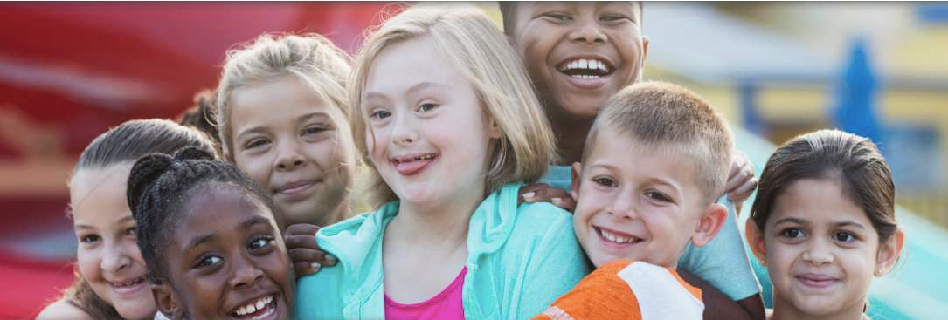

“Universal declaration of human rights”, (20 November 1959), online: United Nations .
“Convention on the rights of the child”, (20 November 1989), online: OHCHR <https://www.ohchr.org/en/instruments-mechanisms/instruments/convention-rights-child> (UNCRC)
Child and Youth Well-Being Act, NB 2022, chapter 35, s.26.
United Nations High Commissioner for Refugees. “General comment no. 9 (2006): The rights of children with disabilities”, (27 February 2007), online: Refworld <https://www.refworld.org/docid/461b93f72.html>
Supra note 2 at Premable para 7.
United Nations High Commissioner for Refugees. “General comment no. 14 (2013) on the right of the child to have his or her best interests taken as a primary consideration (art. 3, para. 1)”, (29 May 2013), online: Refworld <https://www.refworld.org/docid/51a84b5e4.html>
Government of Canada, Statistics Canada. (22 January 2021), online: Household spending, Canada, regions and provinces <https://www150.statcan.gc.ca/t1/tbl1/en/tv.action?pid=1110022201>
“Canada’s food price report - Dalhousie university”, (2022), online: <https://cdn.dal.ca/content/dam/dalhousie/pdf/sites/agri-food/Food%20Price%20Report%20-%20EN%202022.pdf>
Supra note 9.
Supra note 8.
New Brunswick Health Council. “New Brunswick Student Wellness Survey 2018-2019”, (2020), online: https://nbhc.ca/sites/default/files/publications-attachments/SWS18-19%20-New%20Brunswick%20Provincial%20Results.pdf
“N.B. Child Welfare Bill changed to add children's rights, tracking outcomes of youth in care | CBC news”, (10 June 2022), online: CBCnews https://www.cbc.ca/news/canada/new-brunswick/nb-child-welfare-bill-committee-1.6483496
Supra at note 13.
“Combined fifth and sixth reports submitted by Canada under article 44 of the Convention”, (3 March 2020), online: <https://tbinternet.ohchr.org/_layouts/15/treatybodyexternal/Download.aspx?symbolno=CRC%2FC%2FCAN%2F5-6&Lang=en>
Supra at note 13.
Ibid.
Ibid.
Ibid.
Ibid.
United Nations & Committee on the Rights of the Child, 17 April 2013, General comment No 15 [General comment No. 15], at para 16.
Supra note 2, Article 23.
“Variability in Health Service Quality”, (10 February 2021), online: New Brunswick Health Council<https://nbhc.ca/news/variability-health-service-quality>
“Youth access to mental health services: Perceived needs and barriers”, (26 January 2022), online: New Brunswick Health Council <https://nbhc.ca/news/youth-access-mental-health-services-perceived-needs-and-barriers>
Ibid.
Ibid.
Supra, note 2 at para 39.
Steeves, Shelley. “Staff shortages force bed closures at Youth Mental Health Unit at Moncton Hospital - New Brunswick”, (12 March 2021), online: Global News <https://globalnews.ca/news/7693606/nb-youth-mental-health-unit-closure/>
EECD, 2021, Report on Student Outcomes and School Climate NB Schools - Secondary (6-12) Spring 2021 New Brunswick Anglophone Schools Highlights [Report on Student Outcomes and School Climate NB Schools - Secondary (6-12) Spring 2021 New Brunswick Anglophone Schools Highlights].
Ibid.
Office of the Child and Youth Advocate, The best we have to offer: Final report on the youth suicide prevention and mental health services review [The best we have to offer: Final report on the youth suicide prevention and mental health services review].
Ibid.
Supra note 2.
Ibid.
SCN, UN. “Schools as a system to improve nutrition - UNSCN”, (2018), online: UNSCN <https://www.unscn.org/uploads/web/news/document/School-Paper-EN-WEB-8oct.pdf>
Supra, note 13.
Benn-Frenette, Rob. “Opinion | opinion: Bullying isn't just a problem, it should be considered a national emergency based on the statistics | CBC News”, (2 November 2019), online: CBCnews <https://www.cbc.ca/news/opinion/opinion-bullying-rob benn-frenette-1.5335031>
Committee on the Rights of the Child & UUR, 6 December 2012, Concluding observations on the combined third and fourth periodic report of Canada, adopted by the Committee at its sixty-first session [Concluding observations on the combined third and fourth periodic report of Canada, adopted by the Committee at its sixty-first session].
Supra, at note 32.
Supra, at note 13.
Supra, at note 13.
Supra, note 2 at Article 28(1).
Supra, note 2 at Article 28(1).
United Nations High Commissioner for Refugees. “General comment no. 1 (2001), Article 29 (1), the aims of Education”, (17 April 2001), online: Refworld <https://www.refworld.org/docid/4538834d2.html>
Supra, note 47.
Supra, note 2 at article 28 (1).
Human rights indicators a guide to measurement and implementation, ed (Erscheinungsort nicht ermittelbar: United Nations, 2013).
Supra, note 2 at article 28 (1)(a).
Supra, note 47.
Supra, note 47.
Supra, note 47.
Supra, note 47.
Bill 35, An Act Respecting Empowering the School System, 1st Sess, 60th Leg, New Brunswick, 2021 (assented to 11 June 2021), SNB 1997, c E-1.12.
United Nations High Commissioner for Refugees. “CCPR general comment no. 24: Issues relating to reservations made upon ratification or accession to the covenant or the optional protocols thereto, or in relation to declarations under Article 41 of the Covenant”, (4 November 1994), online: Refworld <https://www.refworld.org/docid/453883fc11.html> para 16.
Ibid, at para 18(a).
Ibid, at para 85
Ibid, at para 28.

